THESE 5 MISSIONARY FAMILIES CAME FOR FULL DAY OF TRAINING ON FEBRUARY 6TH, 2024, AND WHAT A WONDERFUL DAY FOR THEIR ORIENTATION! THESE ARE THE NEWEST MISSIONARY FAMILIES CALLED BY THE LUTHERAN CHURCH-MISSOURI SYNOD!

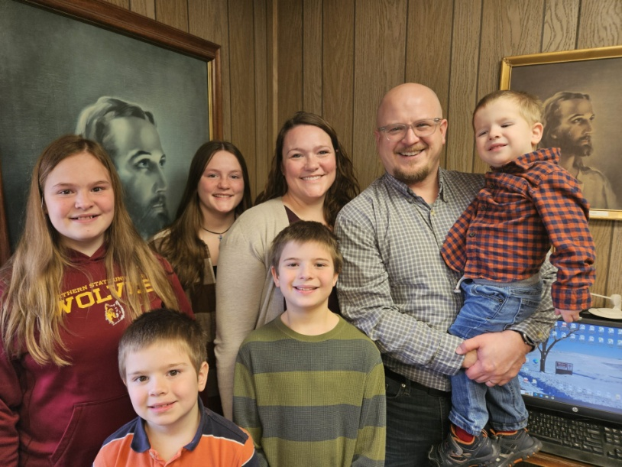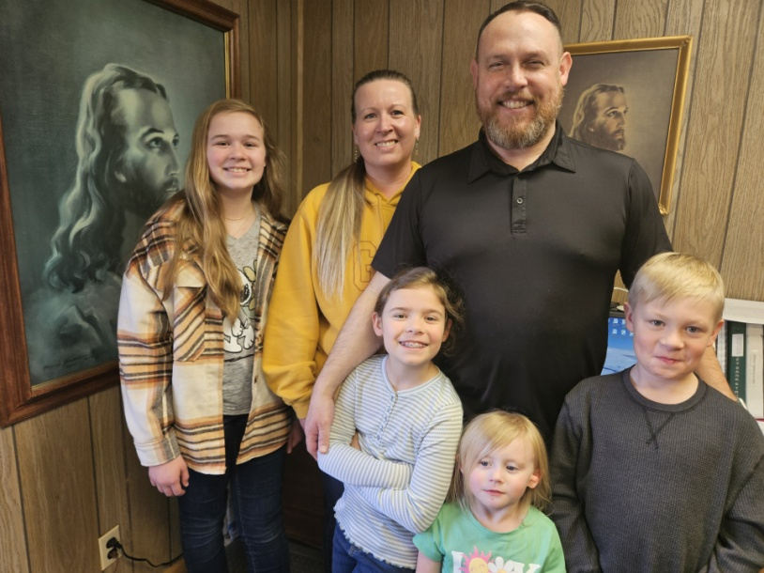
REV. JORDON ANDREASEN AND FAMILY GOING TO ROMANIA TO SHARE JESUS! REV. JONAH DOMENICHELLI & FAMILY GOING TO GERMANY TO SHARE JESUS!
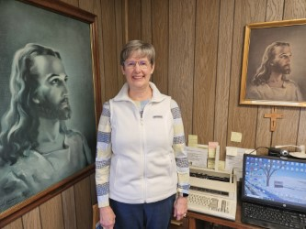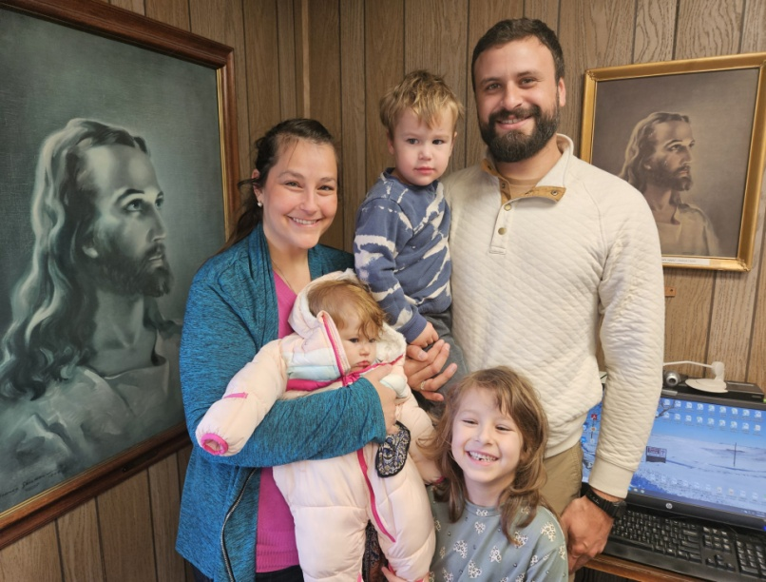
MISSIONARY DANA STIGDON ON HER JOURNEY IN THE DOMINICAN REPUBLIC! REV. ROBERTO WEBER TO TEACH IN THE DOMINICAN REPUBLIC SEMINARY!
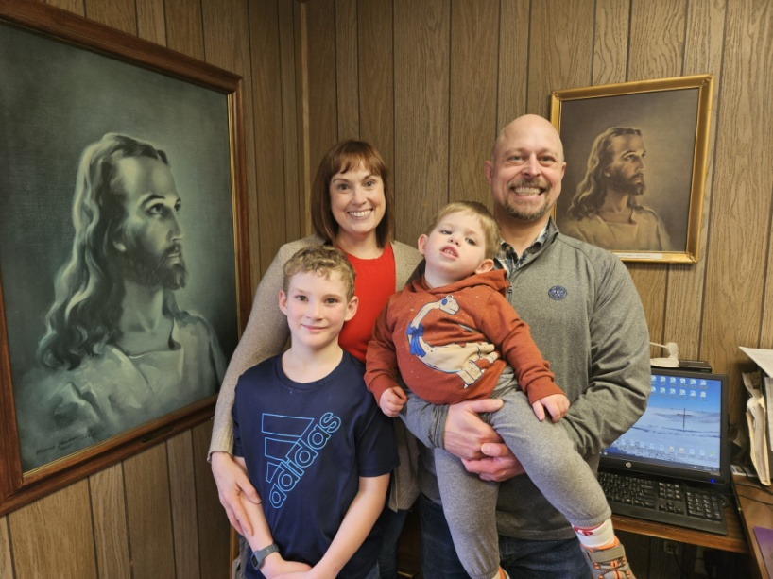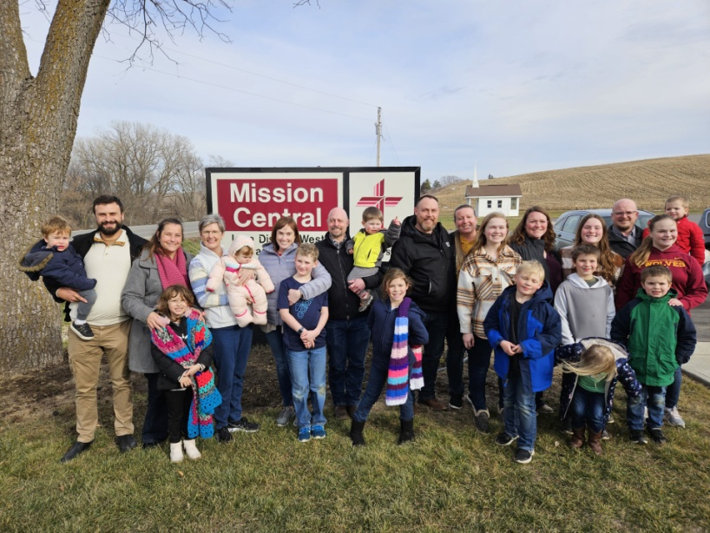
REV. ROSS SHAVER & FAMILY GOING TO TEACH IN THE DOMINICAN REPUBLIC! FIVE MISSIONARY FAMILIES CAME FOR TRAINING ON FEBRUARY 6, 2024!

