The Lutheran Church Missouri Synod

The Taiwan Times

Fall 2022

“Now we know that whatever the law says it speaks to those who are under the law, so that every mouth may be stopped, and the whole world may be held accountable to God. For by works of the law no human being will be justified in his sight, since through the law comes knowledge of sin. But now the righteousness of God has been manifested apart from the law, although the Law and the Prophets bear witness to it— the righteousness of God through faith in Jesus Christ for all who believe. For there is no distinction: for all have sinned and fall short of the glory of God, and are justified by his grace as a gift, through the redemption that is in Christ Jesus, whom God put forward as a propitiation by his blood, to be received by faith. This was to show God's righteousness, because in his divine forbearance he had passed over former sins. It was to show his righteousness at the present time, so that he might be just and the justifier of the one who has faith in Jesus.” Romans 3:19-25

Interrupted by the Gospel
Andrew and Noel Schaff Missionary Newsletter from ChiaYi, Taiwan

Last Sunday on my way to church, I was interrupted by some hard truths. As we drove on one of the more major roads through town we witnessed the longest parade of idols that I've ever seen in the 18 years I've been in Taiwan. There were large groups of people wearing colorful costumes, people with idol heads standing tall on top of their bodies, flags, a band, a karaoke truck, fireworks, men dressed as gods with face paint riding horses, the parade went on and on.

Next, we stopped at a red light by the bus station. I saw a large group of Indonesian Muslims getting off a bus. The women were all wearing hijabs and long dresses. As soon as the light turned green, we drove further up the street to see crowds of people going to the movie theater, playing games at the arcade, and shopping. The crowds of people made me think about idolatry and so many people’s ideas of god.

This made me think of one of the most challenging parts of the Bible in Romans one. What makes it challenging is not the fact that it's difficult to understand. The hard truths are made plain in that text. In verses 18 to 32, Paul writes about God’s wrath and how all of creation is without excuse. It lists numerous sins from first failing to acknowledge the Creator God and being ungrateful, to being given over to greater evils. The list includes lots of things that many people would look at and think are obviously evil, but it equally includes sins that are convicting to us all such as talking badly about others, desiring foolish things, or taking things for granted. The passage makes one point clear- God has a zero-tolerance policy for sin. This is the part of the reading where I cringe. I don't cringe because God's word is bad, I cringe because it hurts me to see so many people passing away around me lost in darkness. Held under God's wrath. I think of one day in Bible class when one of my students asked what Jesus was since he had never heard the name before. I also cringe because when I look at this part of scripture it's like a mirror pointing at the darkness of my heart that so often places foolish idols on the throne where Christ should be.
Apart from God, man is lost in darkness, death, and helpless to save himself. That is why I saw so many lost people creating their own idols. Some of them believing that they can do something to make themselves right before God. Maybe in the US we don't see so much worship of idols in the form of statues, but how often do we see people saying there is no God. Or people running after whatever makes them happy. Or people choosing what parts of the Bible they want to believe and what parts they feel are not for them. No one can justify himself. And God rightly demands perfection. It is the only way God can remain holy. This is the painful truth that one must realize which makes the Gospel so powerful.
That is why in the same section of scripture, Paul writes, “For I am not ashamed of the gospel, for it is the power of God for salvation to everyone who believes, to the Jew first and also to the Greek. For in it the righteousness of God is revealed from faith for faith, as it is written, ‘The righteous shall live by faith.’” (Romans 1:17-18) Then again in Romans three he writes, “Now we know that whatever the law says it speaks to those who are under the law, so that every mouth may be stopped, and the whole world may be held accountable to God. For by works of the law no human being will be justified in his sight, since through the law comes knowledge of sin. But now the righteousness of God has been manifested apart from the law, although the Law and the Prophets bear witness to it— the righteousness of God through faith in Jesus Christ for all who believe. For there is no distinction: for all have sinned and fall short of the glory of God, and are justified by his grace as a gift, through the redemption that is in Christ Jesus, whom God put forward as a propitiation by his blood, to be received by faith. This was to show God's righteousness, because in his divine forbearance he had passed over former sins. It was to show his righteousness at the present time, so that he might be just and the justifier of the one who has faith in Jesus.” (Romans 3:19-25)
Paul understood this firsthand. The Bible talks about how Saul was a blasphemer, persecutor, and even saw to people's deaths. But Jesus interrupted Saul’s life on the road to Damascus. Then he sent Ananias to further interrupt with baptism and the Gospel message. God called Paul to be one who would go to others with the gospel message and interrupt their lives.
That's what we are here in Taiwan to do. We not only teach about God's saving grace in Jesus at Bible study and in Bible class, but we also have everyday relationships and friendships with people here. Within those relationships, we share the hard truth that the creation is without excuse but also all that needs to be done to make us right with God is complete, immediate, and saving in Christ. We share a different picture of God. God’s wrath is revealed in the creation, but we point to God's love in Jesus. The picture we share of God from His Word is a living God who is holy and expects complete perfection. It is also the living God who took on flesh and died in our place and rose from the dead to be our advocate. The hymn “Oh Love How Deep” describes the saving picture of God:
O love, how deep, how broad, how high,
beyond all thought and fantasy,
that God, the Son of God, should take
our mortal form for mortals' sake!
He sent no angel to our race,
of higher or of lower place,
but wore the robe of human frame,
and to this world himself he came.
For us baptized, for us he bore
his holy fast and hungered sore;
for us temptation sharp he knew,
for us the tempter overthrew.
For us he prayed, for us he taught;
for us his daily works he wrought,
by words and signs and actions thus
still seeking not himself but us.
For us, by wicked men betrayed,
for us, in crown of thorns arrayed,
he bore the shameful cross and death;
for us he gave his dying breath.
For us he rose from death again,
for us he went on high to reign;
for us he sent his Spirit here
to guide, to strengthen, and to cheer.
All glory to our Lord and God
for love so deep, so high, so broad,
the Trinity whom we adore
forever and forevermore.

UPDATE
During the Halloween and reformation season we hosted several fall gatherings at our house for students. They really seem to have a fun time some commented that it was the most fun event they've ever attended!

We also celebrated Thanksgiving at Concordia's campus hosted by the foreign teachers. We were able to give thanks to God and eat a great meal with friends from school, church and the community.

We are now beginning to prepare for Christmas. We will have Christmas celebrations at school with the Christmas Carol contests, and the Christmas tree decorating, as well as hosting the foreign teachers in our home for Christmas dinner.

Please Pray
- Please continue to pray for young Christians in Taiwan and those who face persecution from their families for their faith.
- Please pray for all those lost in the World of Darkness this advent season that they may hear the gospel and their lives may be changed by the light of Christ.
- Please pray for the Church around the world, that the Lord would strengthen our faith to worship and serve together regularly.
- Please pray specifically for our students Eric, James, and Anna, that they and their families would know Jesus as their Lord and Savior.
- Please pray for those who come to Salvation church and Andrew’s Friday Night Bible study class that God would be with their nonbelieving family members, bringing them to hear the word of God.

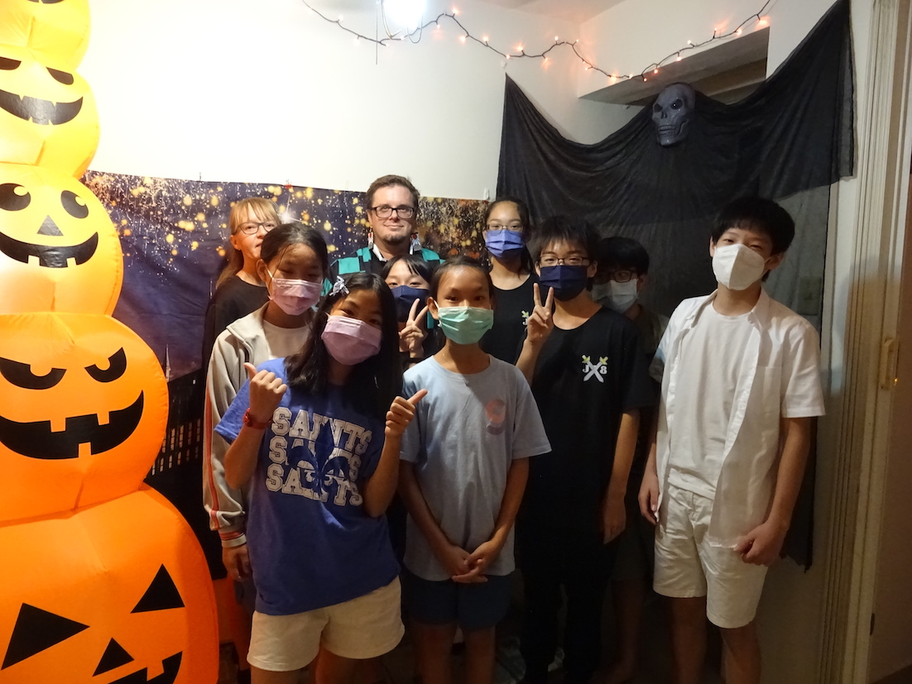

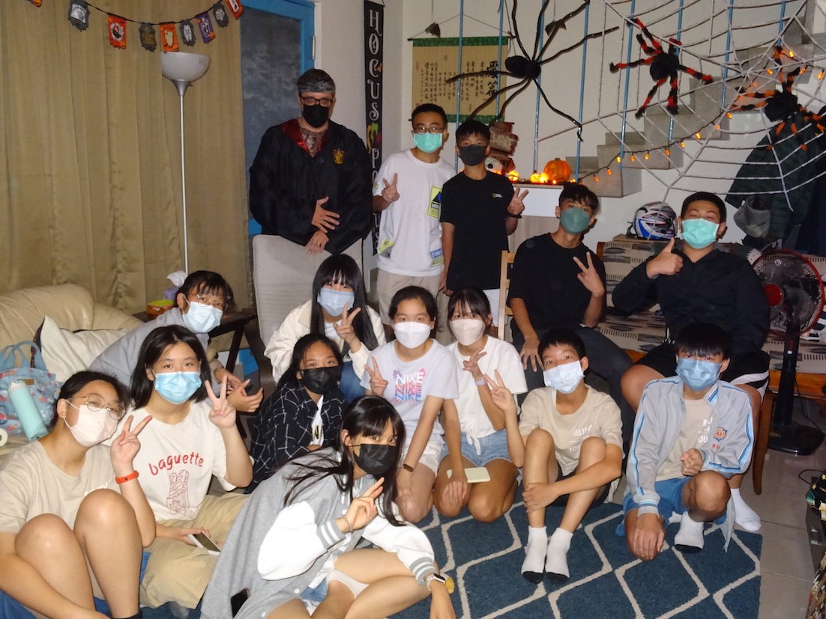

Fall activities with students.

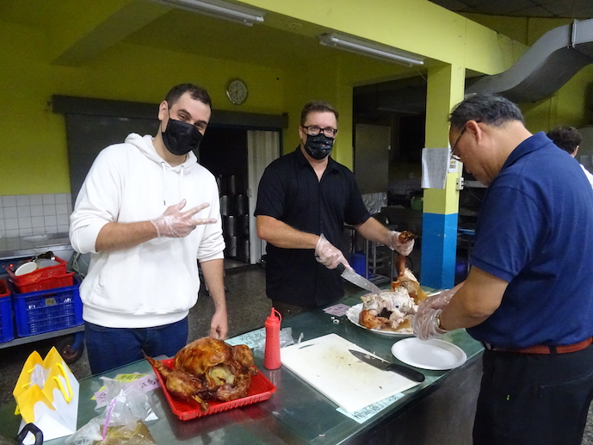
Thanks!
Thank you for all of your prayers and financial support! Your prayers, mail and email continually encourage us. We look forward to sharing more of what the Lord is doing in Taiwan with you in upcoming newsletters.

Peace in Christ,
Andrew and Noel Schaff

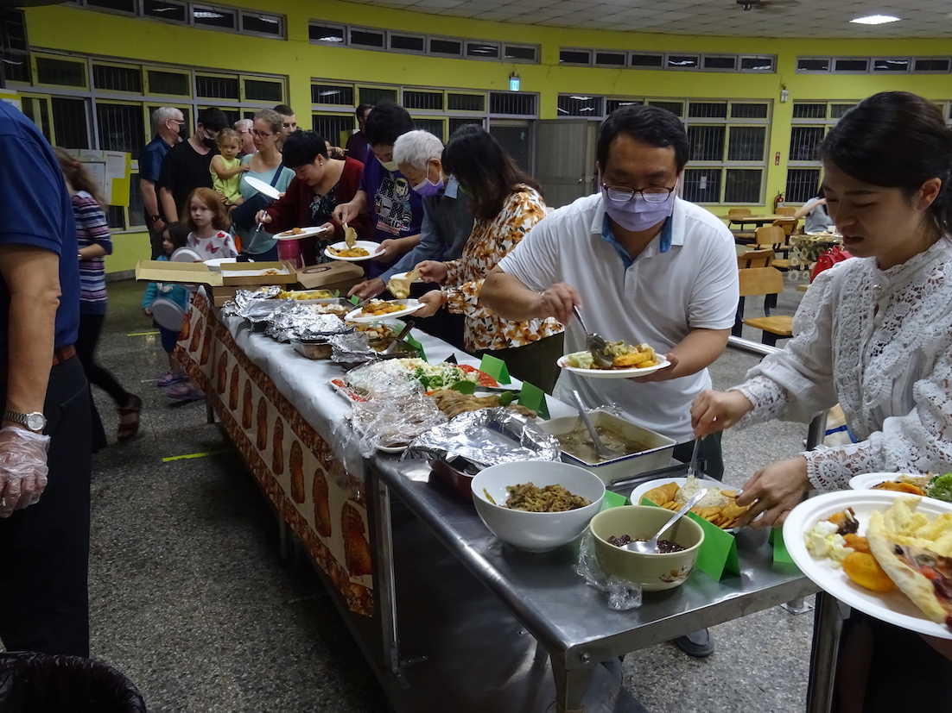

Thanksgiving meal

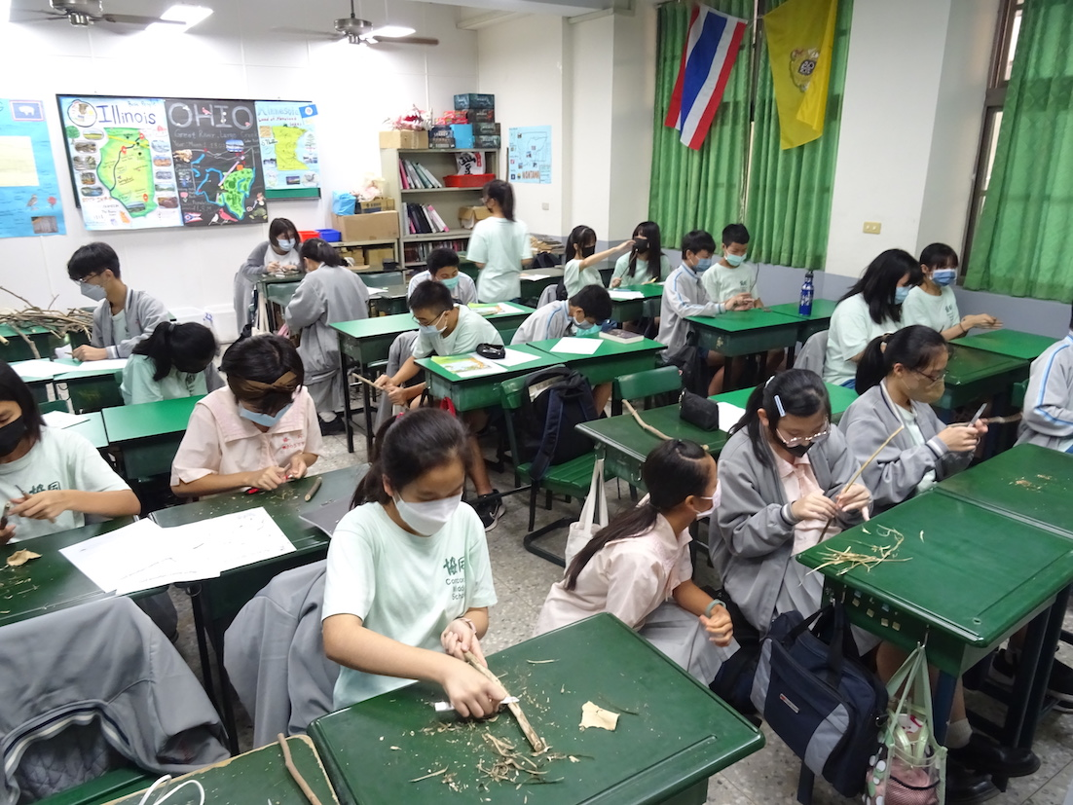

Working on a project in class.

We Thank God for You!

Your prayers and encouragement are greatly appreciated! If you would like to financially support the ministry in Taiwan, please make checks payable to LCMS World Mission, clearly designating for Andrew and Noel Schaff, and send to:

The Lutheran Church Missouri Synod
1333 S. Kirkwood Road
St. Louis, MO 63122-7295

Or adopt us as missionaries through Mission Central in Mapleton, IA. You can contact our friends at Mission Central using the following address:

Mission Central
40718 Highway E 16
Mapleton, Iowa 51034
Phone: 712-882-1029
You can email Gary at Gary.Thies@lcms.org

“I always thank my God as I remember you in my prayers, because I hear about your faith in the Lord Jesus and your love for all the saints.” Philemon 2:4

Andrew and Noel Schaff
#31 Chien-Kuo Rd. Sec. 2
Min-Hsiung, ChiaYi County 621
Taiwan R.O.C.
Phone: 011-886-9-84397996

Pray for Us
Andrew and Noel Schaff
Email us at:

noel_beth19@hotmail.com

About Our Organization…

Continued Story Headline

Back Page Story Headline

