Dear friends and family,

The last time we visited “Mission Central,” our dear friend Missionary Gary asked me to tell all the people gathered what a typical day looked like for me. I was floored (and speechless). It was a good question, but there was no great answer—every day is an adventure in the mission field of Belize.

Since that day I’ve thought a lot about Gary’s question and decided to share how I might answer. For this Mission Moment I thought you might enjoy getting a glimpse of a “typical” Burch weekend.

Saturday mornings we rise early to prepare for church under our home with the Meissner family and our Belmopan congregation. Because we worship in Belmopan on Saturdays, we are free to then travel either north or south for worship on Sundays.

Last Saturday in honor of Pentecost I wanted to do a little something to decorate the sanctuary, so I decided to cut some colorful tropical boughs for our Pentecost “flames of fire.” When I opened the door to the tool cupboard on the carport to get my shears, a startled toad hopped out. He took one look at me, reversed, and dove deep into the bowels of the cupboard. Bowels is appropriate because he had been there at least twelve hours, and had vigorously exercised his. So, to kick off the day I emptied the cupboard of tools, all paraphernalia, and finally one indignant toad. Once I had cleaned the cupboard and returned all treasures to their places, I was ready to begin again. But first I will digress…

The toads and other animals are a normal part of a typical day in Belize. This encounter was with the smaller of two toads that live beneath our house, and the bigger one is often found dozing lazily in our dog’s water dish. Earlier in the week, Herb had just finished digging out the weeds from around a young mahogany tree when a long white snake slithered down the trunk and off into the grass. At about the same time I was the garden digging around the trees when I startled a fairly large tarantula who was miffed that I had dug up her home. It seems that everywhere we look we see new animals and birds—It really is a jungle out there! Now back to Saturday…

Worshipping in a garden setting is marvelous, and can’t be too far from what God envisioned when he put Adam and Eve in Eden. Thanks to our Belize Mission Society friend Kathy Odegard, we have sunflowers blazing and nodding in the morning sunshine, and the papaya is heavy with fruit. Clifford cleans and sets up the chairs on Fridays, so all Herb and I have to do is bring out the altar, set up the sanctuary, and place the hymnals and Bibles on the chairs. Herb and Duane plan the service (of course), but I’m off the hook for that.

Last Saturday we received a text from Duane telling us there were 23 souls in his van, so we should brace ourselves. The Meissners arrived, all passengers disembarked, and we gathered everyone for worship. Church was lively. Most of the congregants are Mayan, and although the adults speak a lot of English, it is still very much their second language. The little children only speak Mayan, so much of the service is lost on them, but Herb and Duane remained serene as they respectfully lead us through the Divine Service. At some point during the service our dog Rosie wandered through and then one of the two-year-olds arrived pushing the toy lawn mower and had to be diverted, but the Holy Spirit remained with us until the final “Amen!”

Pentecost was our last worship service in Belize with the Meissner family. Pastor Duane has accepted a call to be the pastor and coordinator of short-term teams to Belize for the Belize Mission Society. It is lovely that we will still have relationship with him as he travels back-and-forth to the US and Belize, but we will sorely miss him and his family here in Belize.

After the service we had to rush around because Pastor Duane was heading south, and we were going north. We readied the chairs and tables he needed for worship in Seine Bight the following day, and we rushed up and grabbed our suitcases. I should wear a pedometer to keep track, but on a typical Saturday, I probably run up-and-down the steps at least twenty times and that doesn’t even include the times I go either up or down without remembering, “What am I here for?”

At about 11:00 Herb and I were on our way to Mexico. Our first stop was about two hours away at Orange Walk Town where we lunched and picked up our friends Roldán and Ruth Ríos. Roldán is an LCMS Pastoral candidate who is studying for the ministry through the Luther Academy. After lunch, the four of us jumped into the car and continued north. This time, it took only about an hour to get through customs, so we were able to join Genaro and his wife for conversation before evening church in Chetumal., Mexico. Herb is working with both Genaro and Roldán as a pastoral mentor, so we travel to Mexico about once a month.

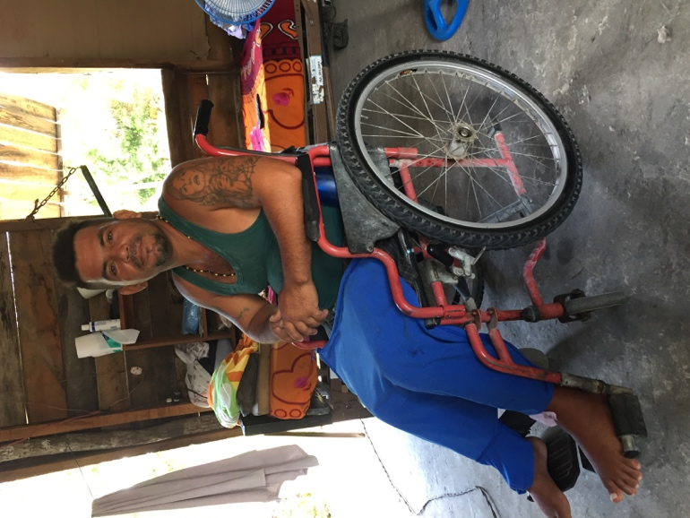
We returned to Orange Walk Town after the service and were in bed by 11:30. The next morning Herb picked up Roldán and his friend Giovanni to make a home visit to a young man who is now confined to a wheelchair. He fell out of a coconut tree about three years ago, and is paralyzed from the waist down. During that trip the men talked about what it might take to bring about 110 wheelchairs into Orange Walk in order to serve many people who are presently immobile. Herb made notes, and we will begin to work toward bringing chairs and a team to Orange Walk Town to serve many disabled people in the community.

That afternoon we traveled with Roldán to Santo Tomás, where we sang and had Bible study. He procured land and built a church in this community after it was flooded about 15 years ago. Every Sunday they have worship and Sunday School, but they have to leave before the sun goes down because they have never been able to afford bringing electricity to the building.
Wilber Alejandro Mejias needs repairs for his wheel chair.

After saying our “Good-byes,” Herb and I headed home. We wanted to get home on Sunday to prepare for the Meissner farewell dinner on Monday evening.

There you have it…a “typical” weekend with the Burch’s. You might think it’s challenging on the mission field, but it’s also a lot of fun. Please pray for us and the Meissner family as we begin a new chapter here in Belize. Pray for Karina and Benjamin, our Bolivian Vicar and his wife who will be joining us to begin work in Valley of Peace. And finally, please pray for the people of Belize and those of us who carry the Good News of Jesus Christ, that all people will hear the Word and believe God’s promises.

Thanks for your prayers and your interest!
Markie and Pastor Herb.

