Lima, Peru
April 3, 2019
Dear Mission Partners,
This past weekend we celebrated what is called the Peru Forum. Representatives from congregations and districts which provide strong financial support for the Peru ministry gather together for updates and strategic planning. Representatives from the North Wisconsin District and the Southeastern District, and from congregations in South Wisconsin, Texas, and Arizona, were here for the discussion. We are hoping to be able to finance two full-time workers in both the Los Olivos and the La Victoria church plants. This is the minimum number of missionaries needed to plant big, strong, healthy congregations in urban Latin America.
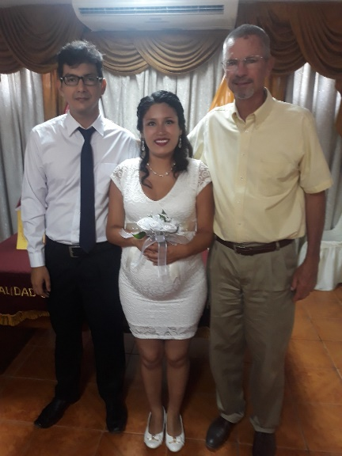
One of the challenges of planting churches anywhere in the world is for the baby church to take a stand for God’s will when the secular culture opposes His will. An example of this in Lima is the dynamic between living together and actually getting married. Very few couples in Lima are getting married today, but rather just live together. So how can a young church stand up for God’s will in this case? Angela has been worshiping regularly with us. She is pregnant and was living with her boyfriend. She wanted to become a member of our church in Los Olivos. We said we would love that, but we want our members to be an example of God’s will for marriage in this society. She understood and her boyfriend agreed and they made plans for a civil ceremony. They were married on a Friday, and she was confirmed in our church the following Sunday. We expect this to be an on-going challenge for missionaries in Lima.
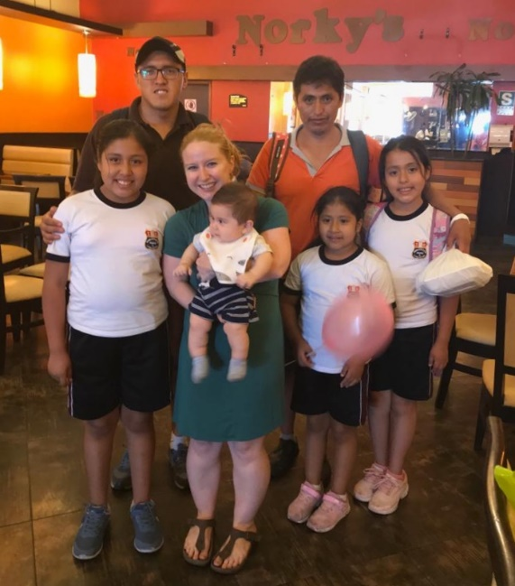
Another church planting challenge is when confirmed members drift away from the church. Their absence is enhanced when the congregation is just getting started. This recently happened in La Victoria. Walter and his three daughters were very active at church. He had a falling out with the director of Castillo Fuerte, and he and the girls disappeared from our church and its ministry. Pastor Osmel and Yolanda made several visits, encouraging them to forgive and come back. They refused, but Pastor Osmel wouldn’t give up. With the help of a visiting missionary who knows all the individuals involved, one more visit was made. It appeared that Walter was convinced of the importance of getting his family back into the church. God-willing, they will make amends and be back in church soon. If not, we will keep trying. A key challenge in church planting is trying to rescue straying sheep. (Pictured are Pastor Osmel, Walter, his three daughters, and Deaconess Caitlin de Ramirez and her baby.)
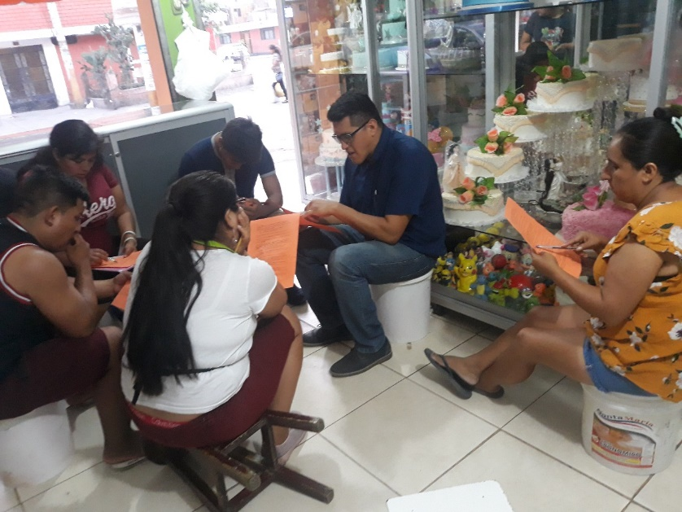
Pastor Osmel continues to expand the ministry of having evangelistic Bible studies in peoples’ homes and places of work. These adults are enjoying learning about what the Bible says about sin and grace, Jesus, faith and salvation. More and more are visiting our worship services. A few have expressed interest in becoming confirmed members. Here is an exciting statistic. Though we are averaging only about 20 at our La Victoria worship services, last Saturday, 41 were in attendance!
A “home” Bible study at the family’s bakery!

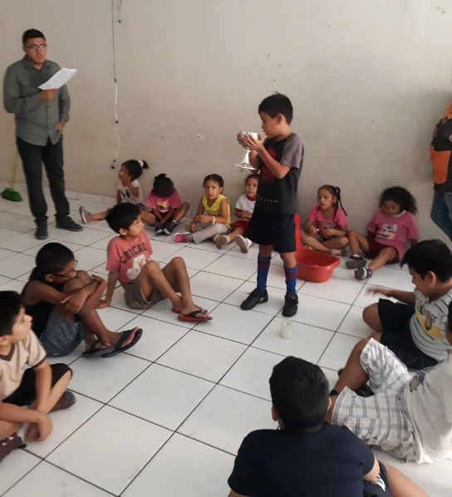
After seeing how much the children and adults enjoyed the Christmas dramas, Pastor Osmel and Yolanda decided to do a Holy Week drama with the children of Castillo Fuerte. About 40 children are practicing three times a week. Costumes are being prepared by the parents, and the scenery by an artistic member. Three songs are included in the drama. The presentation will be in a nearby park on Sunday, April 14, at 10 a.m., with the whole community invited.

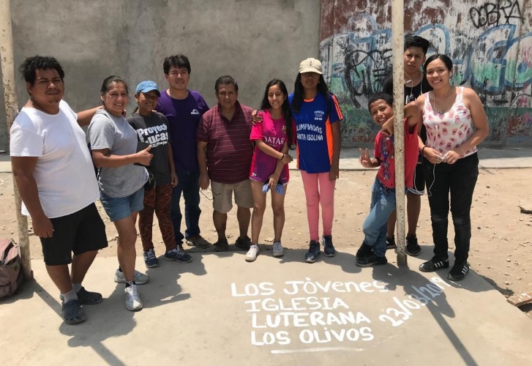
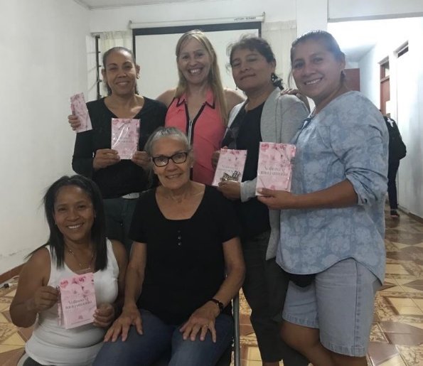
In Los Olivos the youth followed through with their commitment to repaint the lines of the community sports court and are now planning future activities. The ladies’ group has met four times on their own. Each time a different lady has led the Bible study.

With most of our time being spent in Los Olivos and La Victoria, we have not been able to put much emphasis in the San Borja ministry. Until we have a new missionary for San Borja, the ESL classes and English Bible study will not continue. However, three of the ESL participants who have been studying the Bible with us in Spanish will continue to meet on their own.
We are coming to the close of our time in Lima, but we ask that you continue to pray for the ministry here even when we have returned to the U.S. We thank all of you so much for your faithful prayers and financial support during these last seven months.
Fellow servants in God’s Kingdom,
Bo and Barb
Praise the Lord:
- for every group and church and individual who supports the ministry here through offerings and prayers; including all of you who are reading this letter!
- for opportunities to encourage believers to follow the Lord’s will and to rescue those who go astray
- for the evangelistic home Bible studies that Pastor Osmel is leading in La Victoria
- that the youth group and ladies’ group in Los Olivos are continuing to grow

Please ask the Lord:
- to bless all the plans made in the Forum and to guide the search for more workers here in Lima
- to bless Angela and her husband Juan Carlos in their marriage and to draw him to a closer relationship with Jesus
- to bless Walter and his family and keep them in the faith
- to bless every person involved in home Bible studies
- to bless the Los Olivos youth and ladies’ groups
- to bless the small Bible study group in San Borja with consistency and growth

