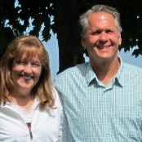
That They May Know YOU
“And this is eternal life, that they may know You, the only true God,
and Jesus Christ whom You have sent.” John 17:3
The Newsletter of Pastor Larry and Tina Matro, LCMS missionaries serving in Papua New Guinea
MARCH 2019
MEET THE 2019 MLS SEMINARIANS FROM THE GUTNIUS LUTHERAN CHURCH!
“The saying is trustworthy: If anyone aspires to the office of overseer, he desires a noble task.” 1 Tim 3:1 (ESV)
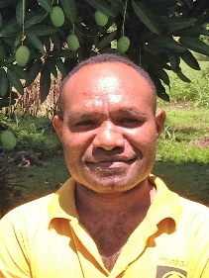
We informed you last month that the project to provide scholarships for Martin Luther Seminary (MLS) students was fully supported. Thank you! This month we want to introduce you to the 6 men who have benefited from the scholarships. They were asked to answer the question, “Why do you want to be a pastor?” (Their responses may have been modified for clarity or space.)
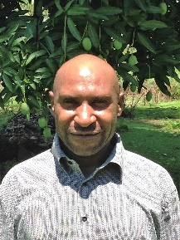
Ezekiel Ene responded: “I want to teach, preach and defend the death and resurrection of the Good News of Jesus Christ. I want to use my Lutheran method to show what God has done in Christ for the world.” (Ezekiel will be a vicar in 2020.)
Iyana Allen wrote: “I want to proclaim the Word of God to the remote places where people don’t know the Word of God, in spite of the dangers that are there. I am willing to go to another country, too, where other people don’t want to go. (Will the LCMS be willing to send me?)” (Allen graduated in 2018 and is writing his Bachelor of Theology thesis this year.)
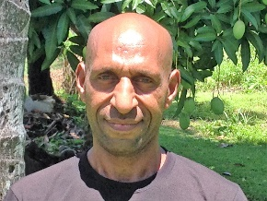
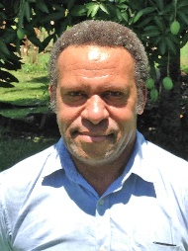
Pastor Mupak Isingi answered: “I want to preach the Gospel of Jesus Christ to all people by word and deed in these perilous times for many are lost in sin and they need healing of their souls.” (Pastor Mupak, who is about 50, graduated in 2014 and served as a high school chaplain for 4 years. He is here in 2019 to write his Bachelor of Theology thesis.)
Kandata Malak wrote: “I want to preach and teach the Gospel, rebuke and correct the abuses of the Scriptures and Sacraments, extend the Gospel to remote areas, restore the fading public worship orders of service, pass on to others what my father, Pastor Malak, passed on to me about the Holy Scriptures and live a life dedicated to prayer and the reading of God’s Word. The desire to be a pastor is a calling from God.” (Kandata is in his 3rd year of study at MLS.)
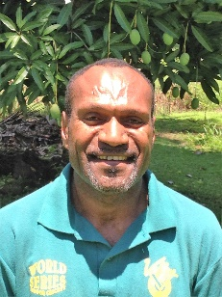
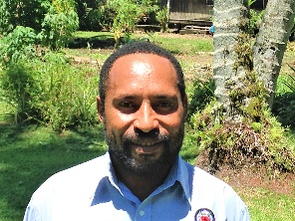
Benson Pindao replied: “There are many Gutnius Lutheran Church Christians who have been influenced by false teachings which have confused them. So I want to study real theology of the Lutheran Faith to rescue those who have lost their faith.” (Benson will be a vicar in 2020.)
Israel Wia answered: “I will minister in my church so that the Word of God is proclaimed in its complete truth and purity. I want to give personal and spiritual guidance so Christians do not fall away in trouble and persecution. I want to preach the Gospel Truth to those who believe and those who do not believe.” (Israel is the son of a pastor and will be a vicar in 2020.)
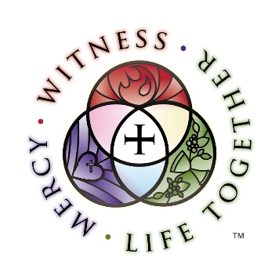
Join us in thanking God for these men and asking Him to keep them faithful in their confession and diligent in their studies. Pray also that the Gutnius Lutheran Church encourages and receives these men as vicars and pastors and are blessed by what they can and will do among them when they preach and teach the Gospel of Jesus Christ!
Thank you for your faithful and generous support! You are a blessing!
God bless you!
Pastor Larry & Tina Matro
larrytinamatro@gmail.com
Please visit the LCMS International Missions website…

https://international.lcms.org

