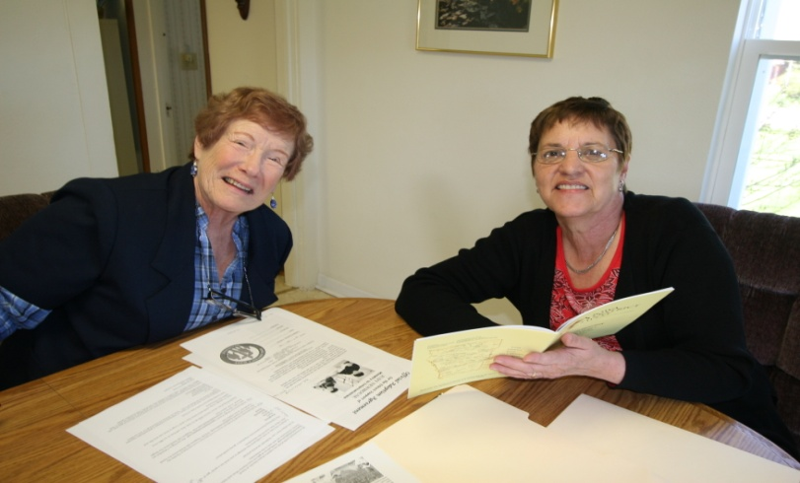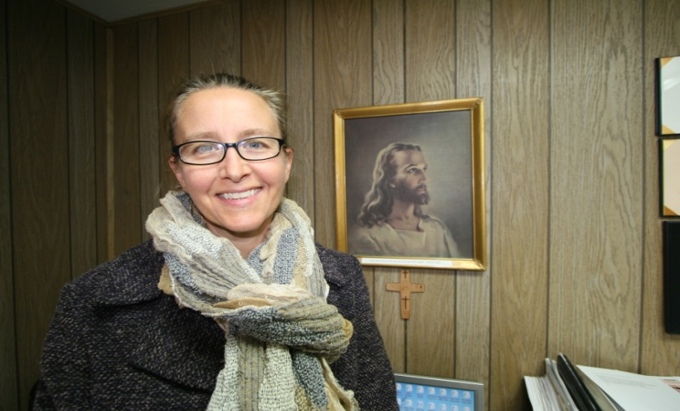
GOD BLESSED US WITH OVER A HUNDRED OF THESE VOLUNTEERS THAT RECEIVE NO PAY
FROM ALL BACKGROUNDS AND ALL WALKS OF LIFE AND JESUS LIVES IN THEIR HEARTS!!!
VOLUNTEER PHYLLIS BROKEMA, BLAIR, NE. & PAM KOVARNA, 19 YEAR SECY! OUR NEWEST IN OFFICE SECRETARY FROM DANBURY, IOWA SONYA WESSLING!
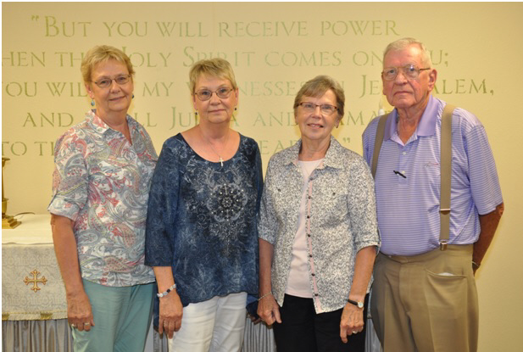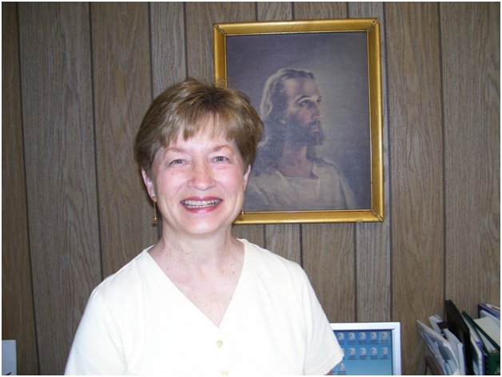
THESE 3 SISTERS ARE ALL VOLUNTEER TYPISTS FROM IOWA TO ARIZONA!!!! VOLUNTEER TYPIST COLLEEN CLASSEN FROM UTICA, NEBRASKA!!!
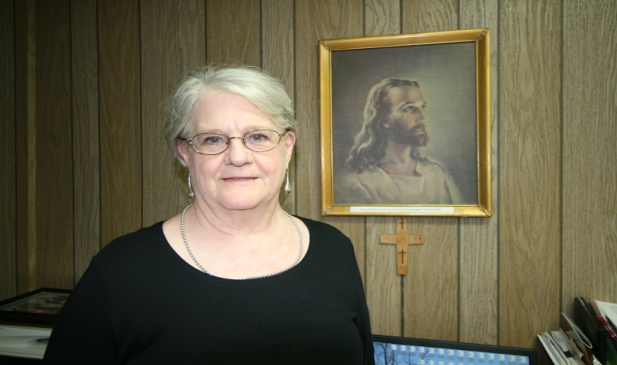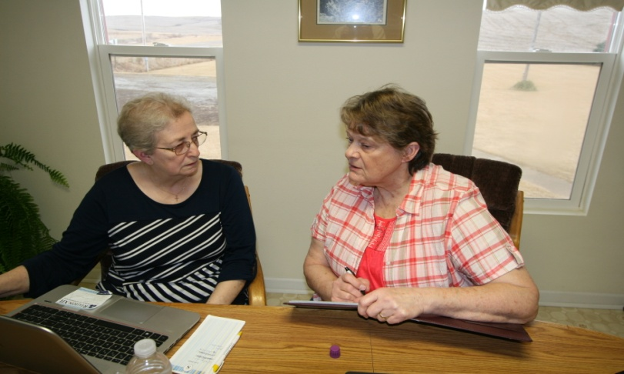
VOLUNTEER SECRETARY CYNTHIA ERNST FROM SCHLESWIG, IOWA!!! VOLUNTEER PRAYER WARRIORS, SHARON IRWIN & LADONNA STANOSCHECK
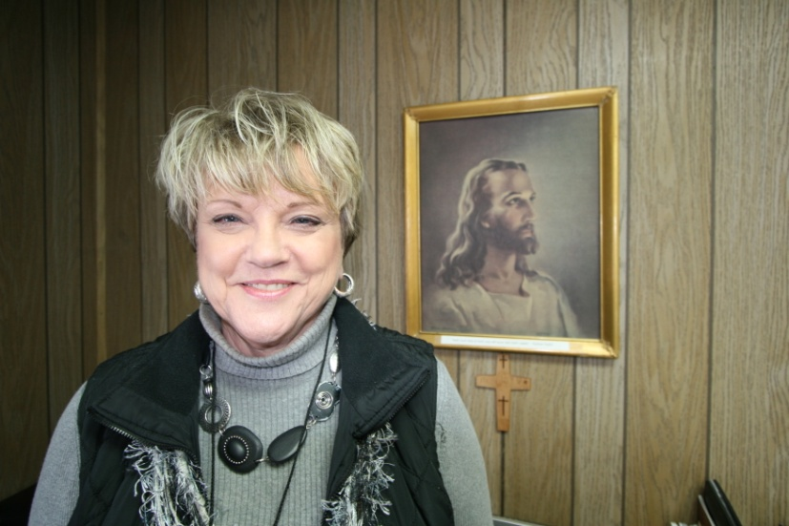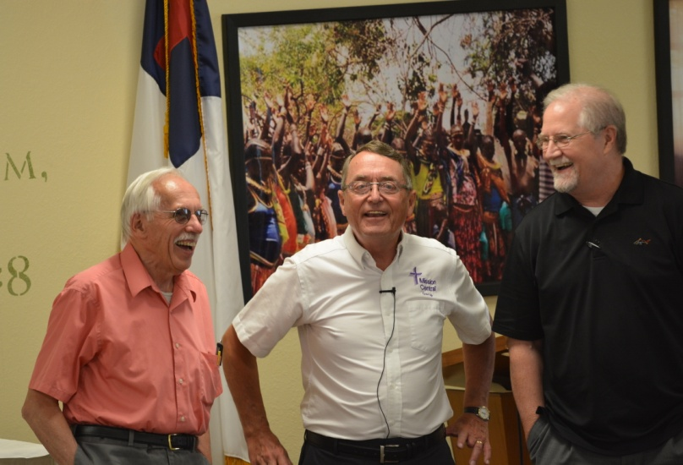
VOLUNTEER E-MAIL SPECIALIST LINDA FEHL FROM NORWALK, IOWA!! DRIVER ED BOHLMAN, OMAHA, GARY, REV. JOHN FALE FROM ST. LOUIS!

