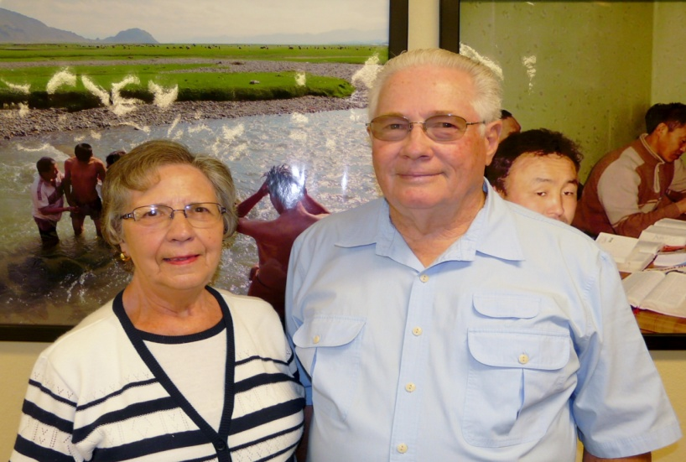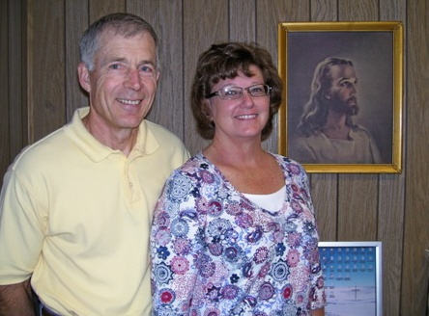
VOLUNTEERS ARE THE VERY “BACKBONE” OF LORD’S WORK HERE AT HIS MISSION
CENTRAL, WHERE GREAT MIRACLES HAPPEN EACH DAY WITH NOT NORMAL PEOPLE!
VOLUNTEER DRIVERS, KEITH AND SHIRLEY LAMBERT FROM HULL, IOWA!! VOLUNTEER BEEF DONATERS JIM AND CINDY NELSON FROM CRESTON, IOWA!!
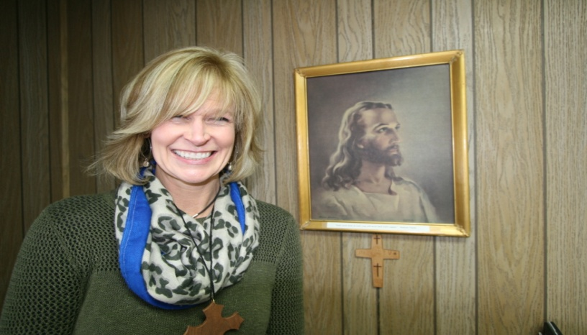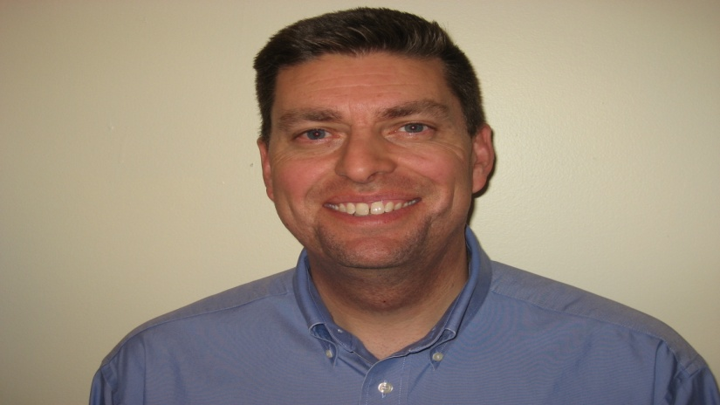
VOLUNTEER E-MAIL SPECIALIST CINDY WILLHAM FROM DES MOINES, IOWA!! VOLUNTEER WEBMASTER DAVE REDDEL FROM OMAHA, NEBRASKA!!!
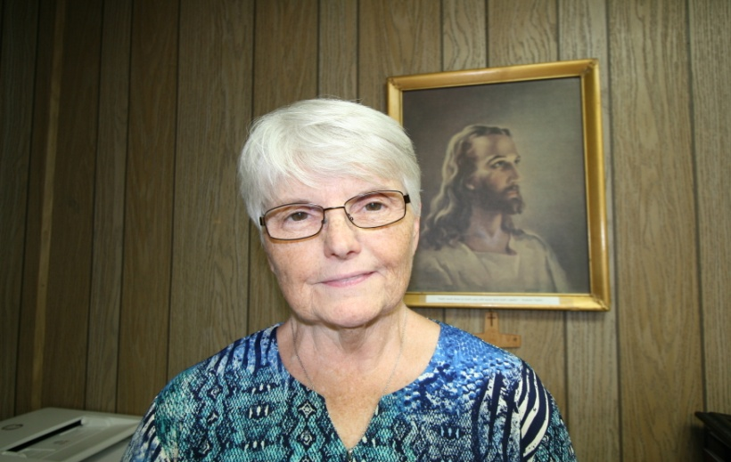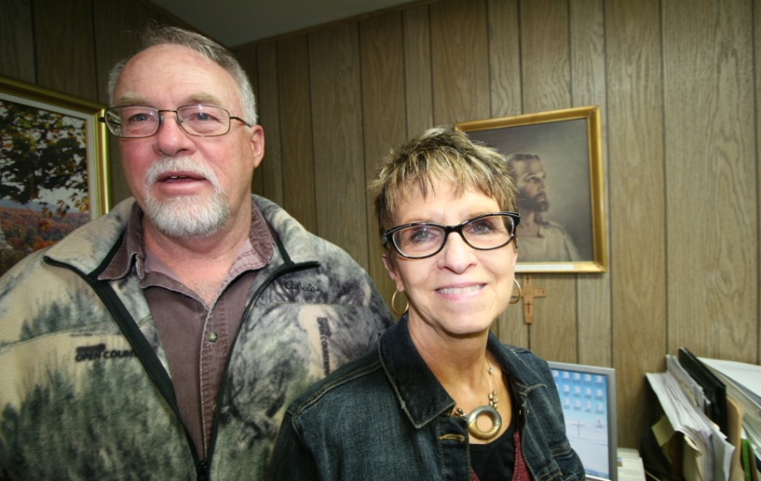
VOLUNTEER TYPIST LESLIE SCHENCK FROM CLARINDA, IOWA!! VOLUNTEERS BRUCE & JAN HENDERSON FOR REPAIR & TYPING, ODEBOLT, IA.!
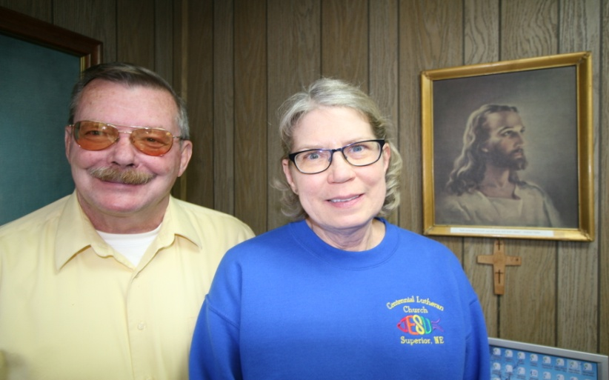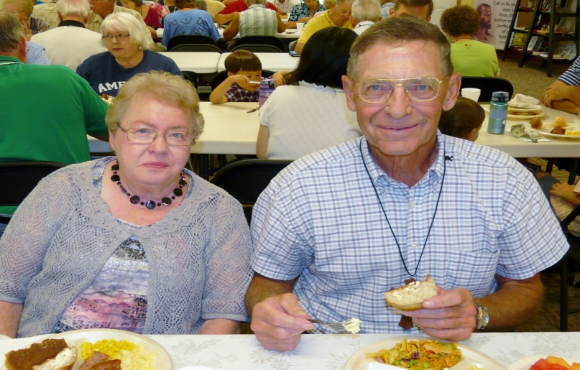
VOLUNTEER PILOT FRED MEYERS & NAN FROM SUPERIOR, NEBRASKA! VOLUNTEER SECRETARY ZOLA KAFTON & WAYNE FROM MAPLETON, IOWA!!

