Lima, Peru
March 13, 2019
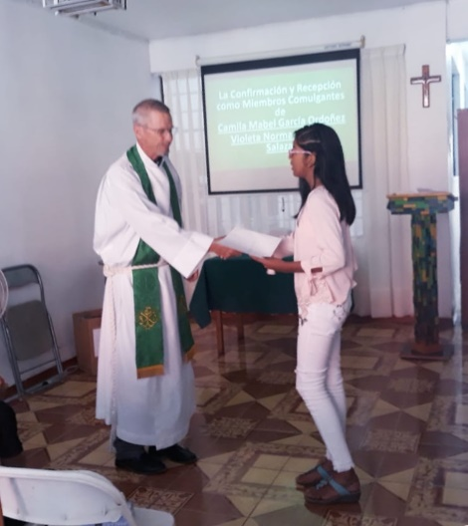
Dear Friends,
Thank you for praying for the mission in Peru!
In the Los Olivos church plant, the Lord is blessing in several ways. First, we are in the process of celebrating four confirmations, one 12-year-old girl and three adults. At first, we were disappointed when they told us they couldn’t all be confirmed on the same Sunday because of family trips. But it ended up being a blessing, because each of them invited family and friends and we would not have been able to receive these guests well if they had all come on the same Sunday. Another benefit is that we get to eat cake four different times. Our little Los Olivos church now has about 22 active confirmed members.

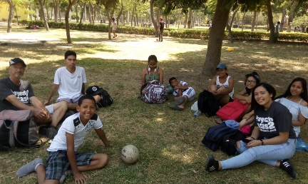
Second, a small youth group has been born! Two Saturdays ago, six youth and four adults went to a park with a swimming pool. We had a devotion, played soccer and volleyball, went swimming, ate together and had a great time. Our next event is a service project. In two weeks, we will repaint the lines of the community sports court. We hope to invite some of the unchurched youth of the community to help us! We are praying this youth group will grow a lot over the next year.
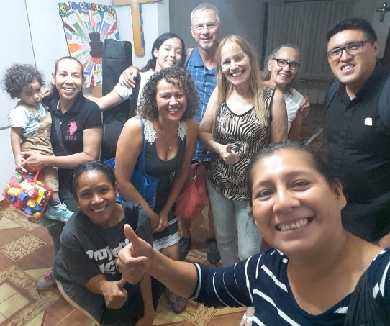
Third, we have a ladies’ group in formation. Barb has been leading a Bible study on prayer for the last 4 months. We’ve had between four and nine ladies attend each week. On a few Thursday evenings, when Barb could not be there, other ladies led the study. We have several very capable Bible teachers in the group and great interest among the ladies to keep the group going. They would like to continue meeting for Bible study, prayer, fellowship, and service. They have already planned their next meeting for later this week.
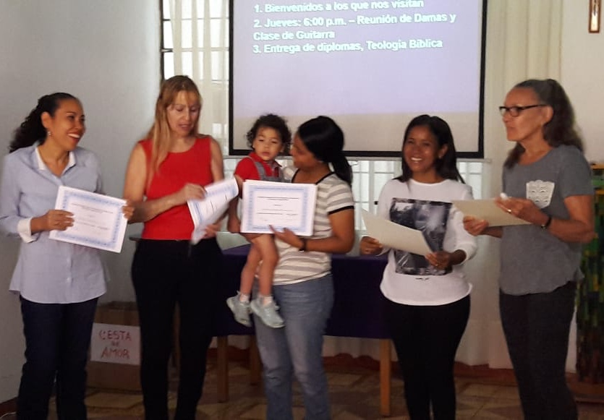
Fourth, Bo just finished teaching a 17-week course on the theology of the Bible as part of the new lay leadership training program. We started with 12 men and women but only 5 ladies finished and were awarded their certificate last Sunday. Bo realizes that we should have started with a shorter course, but the good thing is that more members are now aware of the importance of lay leaders having a strong Biblical and doctrinal base.
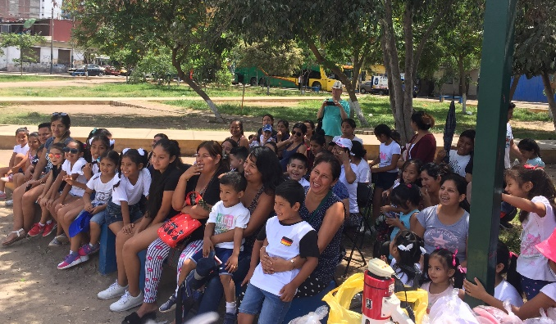
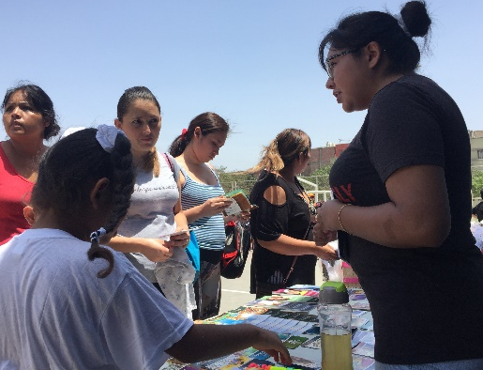
In La Victoria, every special event at Castillo Fuerte is an opportunity to reach more of the parents. On February 22, we had the closing program for the children’s summer session. Lots of moms and a few dads joined their children for songs and games in the park. Bo gave a brief message on “Characteristics of a Happy Family,” and we handed out Bible story books to the children. Yolanda worked hard at getting names and addresses of parents who would like a visit from Pastor Osmel.

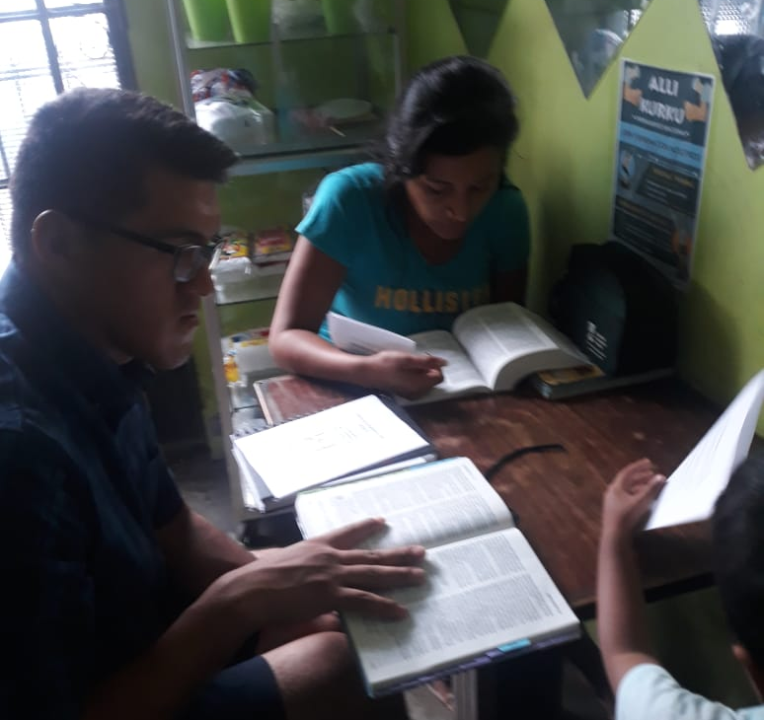
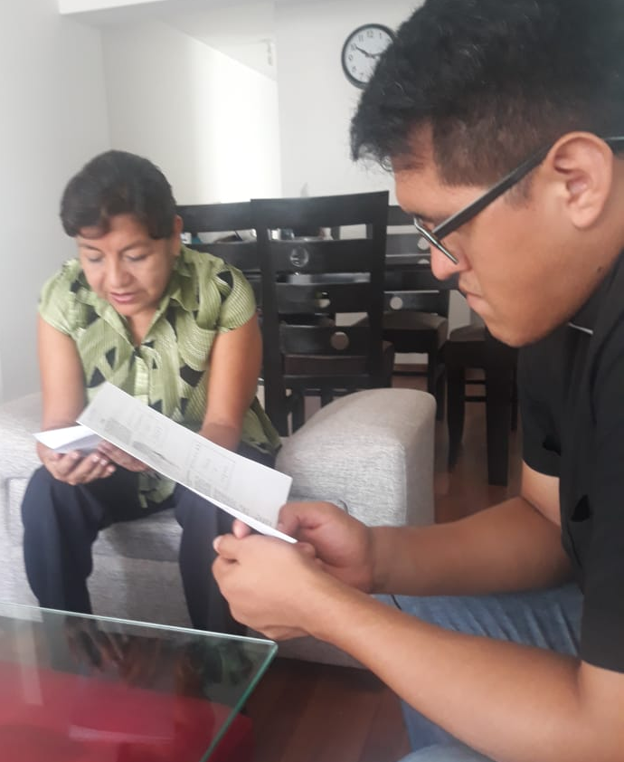
Those names have helped Pastor Osmel begin even more home Bible studies. Last month we told you that he had been able to lead evangelistic Bible studies with 9 adults in 4 different homes. Since then, he has started studies in 7 more homes with 15 more adults! A growing number of these adults are visiting our worship services.
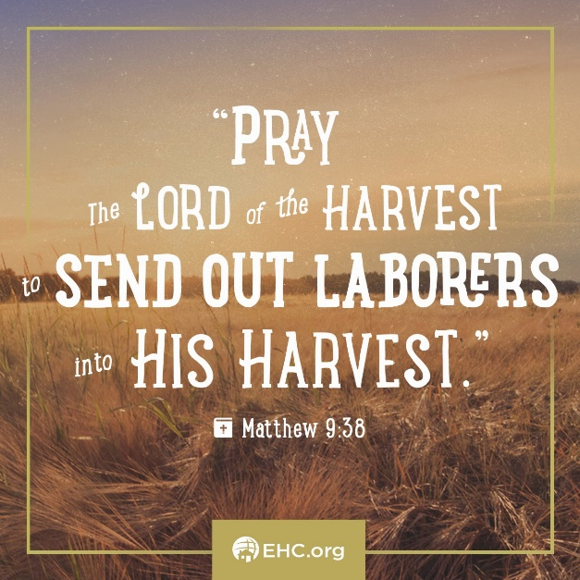
Our whole Latin American team is working hard at getting more missionaries in place in Lima, to join Pastor Osmel and Yolanda. One of these workers will be a vicar from Lima who will finish his theological studies in the Dominican Republic in June. Another may be a young, Peruvian man and his family who worked with the mission a few years ago but had to move to the interior of the country. He is known to be a good evangelist. We are also inviting a pastor from Paraguay whose wife is Peruvian. If each of these families agree to come to serve in Lima, we will have a team of four families sharing the gospel in this huge city.

Praise the Lord:
- for our new members in Los Olivos
- that a youth group and a ladies’ group are being formed
- for all the students who worked on the theology course
- for the new evangelistic home Bible studies that Pastor Osmel is leading in La Victoria
- for leading us to workers who may be able to join this Lima mission
- for our new granddaughter, Isla Grace, born March 11

Please ask the Lord:
- to continue to bless our growing congregation in Los Olivos
- to bless our efforts at starting strong youth and ladies’ groups
- to help the congregation also start a men’s group
- for blessings on the new evangelistic Bible studies in La Victoria
- to lead more missionaries to want to come to Lima

