February 18, 2019
Dear Friends of the Mission in Lima,
In our last letter, we asked you to be praying for three outreach events. Thanks so much for your prayers. Here is how the Lord answered.
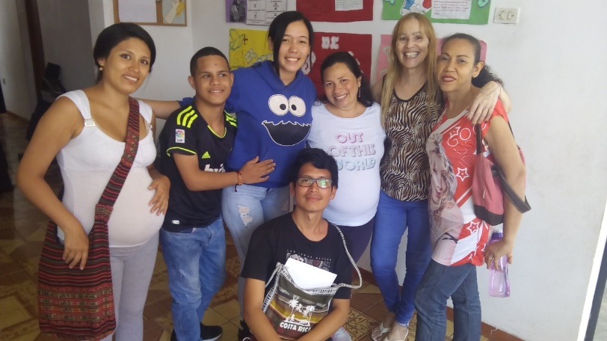
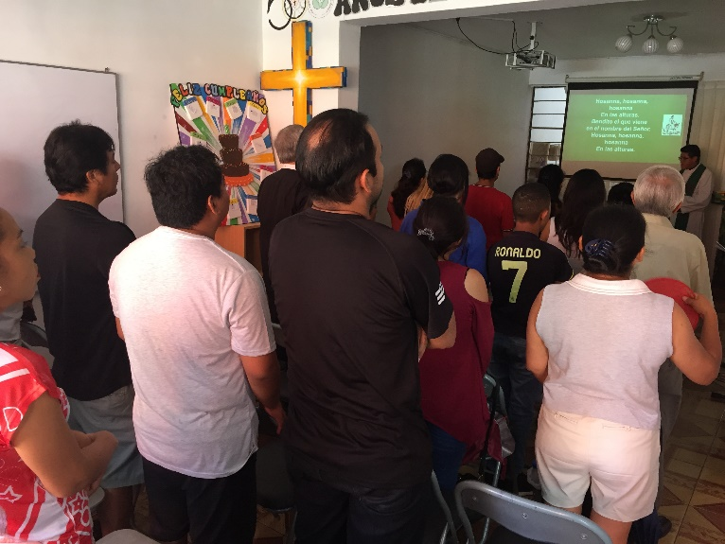
We had a fun Friendship Sunday yesterday in Los Olivos. The worship service was designed to share the gospel with unchurched guests and included the confirmation of a young college student who has been helping with the music ministry. (He is pictured below kneeling with some members and friends.) The Lord blessed us with five first-time visitors. Our members were very welcoming and brought lots of food for the fellowship hour. We were surprised at how many people stayed and visited into the early afternoon. It’s great to see the friendships growing and to see our members reaching out to friends and family.

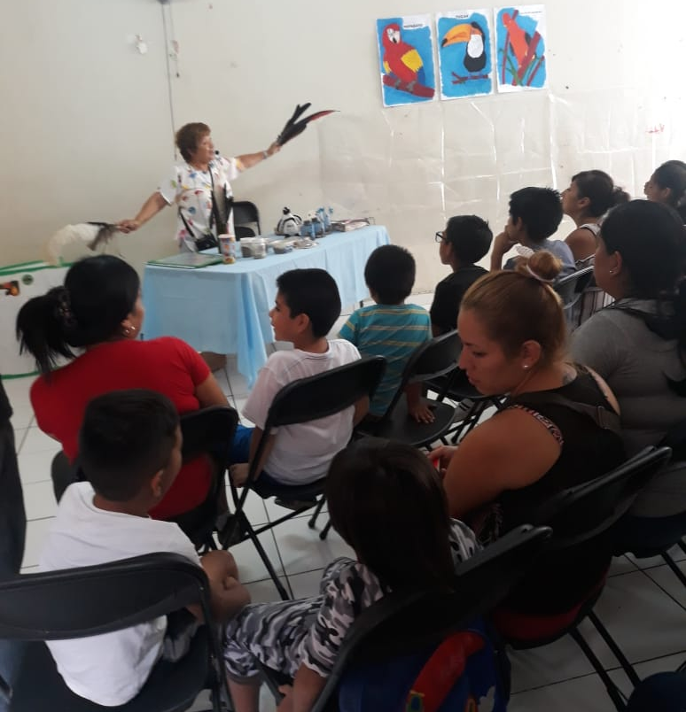
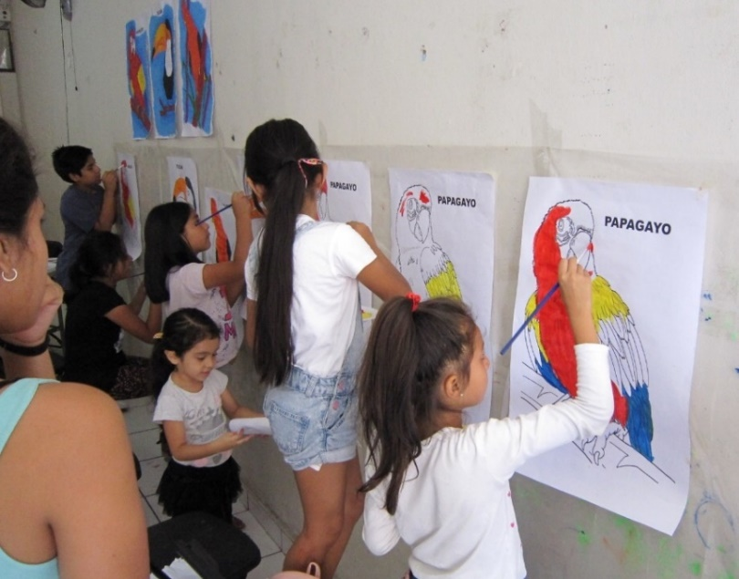
On January 30, we had the outreach event in La Victoria which highlighted Peruvian birds as part of God’s creation. A local, Christian zoologist gave a fascinating presentation on birds, and Pastor Osmel gave a gospel presentation pointing to God as Creator and Jesus as Savior. The children painted huge posters of their favorite bird. We are thankful that 21 parents attended. Follow-up takes time, but it is in process.
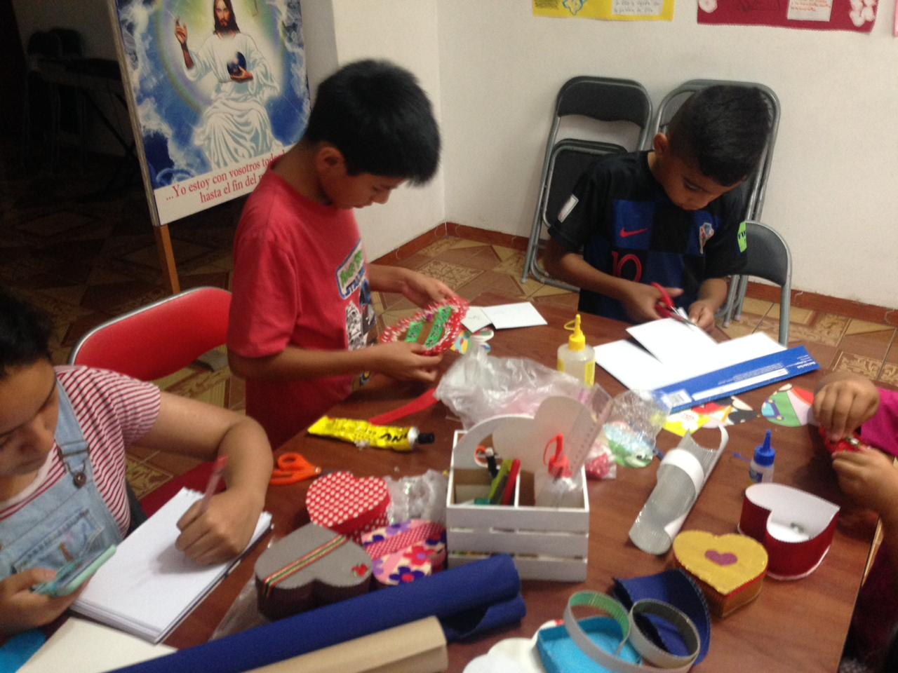
In early February, Violeta led craft classes in Los Olivos. They were mainly attended by the children of our congregation, but two preteens from the neighborhood also participated. We had hoped that more children from the neighborhood would attend, but the congregation can now try out more of these simple outreach events.

Sometimes it’s difficult to plan and work and reach out, especially when we don’t see immediate results. Barb was feeling rather discouraged about this recently. But the following Sunday Pastor Osmel preached on the miraculous catch of fish in Luke 5. He reminded us that in the Lord’s timing the “catch” will be great and our efforts blessed. Barb was encouraged by that sermon, and it was exciting to see how the Lord blessed Pastor Osmel’s efforts the very next week. For a long time, he had been trying so hard to get parents of our Castillo Fuerte children interested in studying the Bible but had little success. Then, instead of inviting them to church for the Bible study, he offered to hold the Bible studies in their homes. What a difference! Last week Pastor Osmel was able to hold evangelistic Bible studies in 4 different homes with 9 adults participating! He is invited to return to all four homes, and he is scheduling more home Bible studies this week.
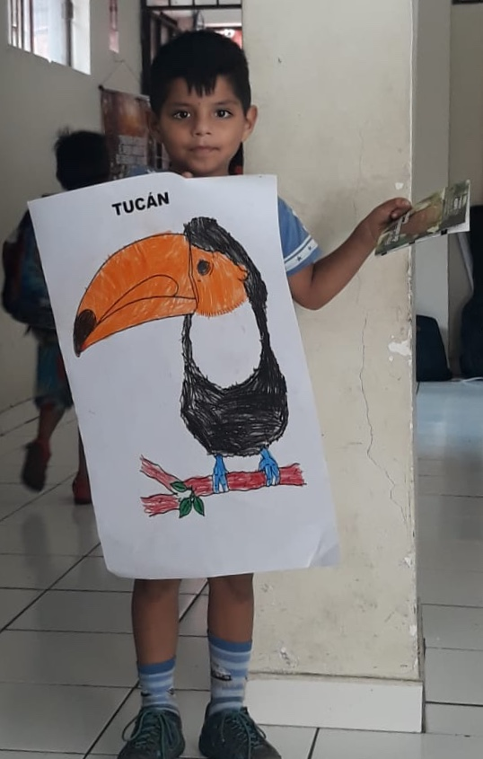
Praise the Lord:
- for the opportunity to share the gospel through our Friendship Sunday, bird seminar and crafts workshop
- for the new evangelistic home Bible studies that Pastor Osmel is starting in La Victoria
- for the Lord’s encouragement when we feel discouraged

Please ask the Lord:
- to continue to guide us in effective follow-up on the contacts generated by the recent outreach events and the contacts from the ESL classes in January
- for blessings on the new Bible studies in La Victoria
- to bless our efforts at starting a youth ministry in Los Olivos
- to continue to bless the people attending our Sunday evening San Borja Bible study

