January 28, 2019

Hi Everyone,

Thanks for being part of this ministry in Lima.

January 5th was a happy day for us as we welcomed Pastor Osmel and Yolanda back to Lima after their Christmas and New Year’s trip home to Bolivia. They brought Osmel’s mom, Lucia, back with them for a three-week visit. It was fun getting to know her and learning more about Bolivia through her.
That same day, January 5th, a group of ten short-term missionaries arrived from Mequon, WI. They worked long and hard with us every day for a week.

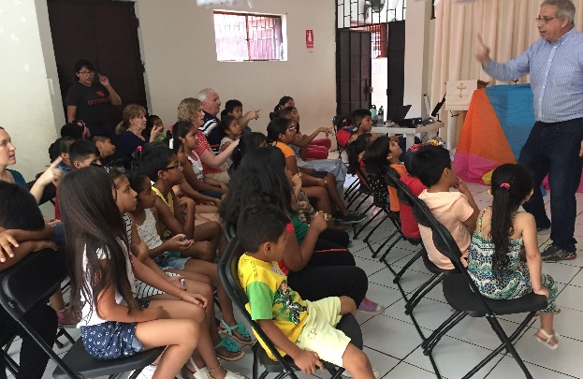
In the mornings and early afternoons, they led English classes for about 55 children at Castillo Fuerte in La Victoria. Their teaching was bilingual, and included Bible stories, Bible songs, crafts, and games in the park. The theme for the week was “Jesus is God and Savior.” It’s difficult to measure the results of this ministry, but these children heard the gospel every day, and many of their parents were able to listen in from time to time.

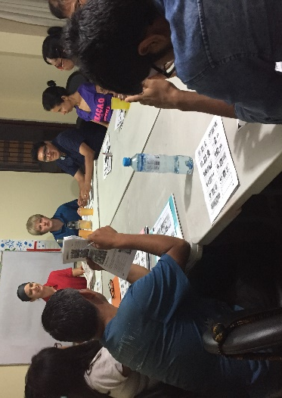
Two pharmacists from the team also taught a seminar for parents on the prevention of colds and flu, and on adult mental health.

In the evenings, in San Borja, the team taught intensive ESL classes to 32 adults divided into groups of beginner, intermediate and advanced students. The classes were lively and fun, and friendships were formed between the teachers and many of the students. This ministry resulted in new contacts for evangelistic follow-up. Already, 6 of the students have studied the Bible with us since the team left Lima.

We loved working with this team and are very thankful for each team member’s dedicated and loving ministry here in Lima. The group also kindly left many resources for on-going teaching of Bible and English to children and adults.

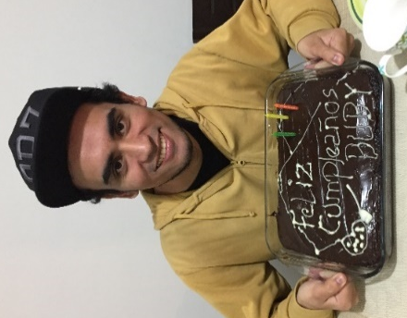
Looking ahead, we have several pre-evangelism events which will take place before our next newsletter, and we invite you to be praying for the Lord’s blessings. First of all, in La Victoria, this Wednesday, January 30th, children and parents will gather in a park near Castillo Fuerte to learn more about the birds of Peru and their Creator. This event stems from the giftedness of one of our members. Buby is an artist and loves to teach children to draw and paint. The children will be able to paint pictures of three beautiful Peruvian birds; and children and parents will hear about each bird’s awesome Creator and about His love for us in His Son Jesus.
In Los Olivos, a new member will lead a series of four craft classes during the first two weeks of February for children that live around our church. Violeta is a talented teacher of crafts, and she loves to work with children. Bo and other members will be on hand to meet the children and to follow up with their parents.

Also, since November our Los Olivos members have been praying for the conversion of specific family members or friends. We are planning a February 17th Friendship Sunday worship service to which these family members and friends will be invited.

Praise the Lord:
- for the Mequon, WI, team members and their significant contribution to our Lima ministries.
- for Buby’s and Violeta’s talents and willingness to use their gifts to reach into these neighborhoods with the gospel.

Please ask the Lord:
- to guide us in effective follow-up on the contacts generated by the short-term team.
- for blessings on the “bird” and “craft” outreach events in La Victoria and Los Olivos:
- for many neighbors to participate
- for preparation of materials and presentations
- for a desire among the participants to learn more about Jesus

- for blessings on our first “Friendship Sunday,” the 17th of February:
- for the Lord to be working in the hearts of our friends and family members who will be invited to this special event
- for an understanding of how best to use Scripture, message, and song to effectively present the gospel
- to continue to work in the lives of Solange, Elizabeth, and Nelson in La Victoria, and Dante in San Borja, all of whom are just beginning to get into the Word
A few more pictures from the Mequon team’s ministry in Lima:
