December 31, 2018

Dear Partners in the Gospel,

We pray you all had a joyful Christmas celebrating the birth of our Savior Jesus. Our Christmas was very different here in Peru, but it was fun to learn some of the special Peruvian Christmas traditions, and use them to share the Christmas gospel.

In our last letter we told you about the Christmas custom of the chocolatada. Thank you for praying that our chocolatadas would be good evangelistic events.
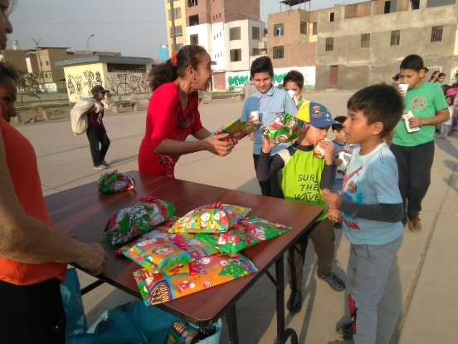
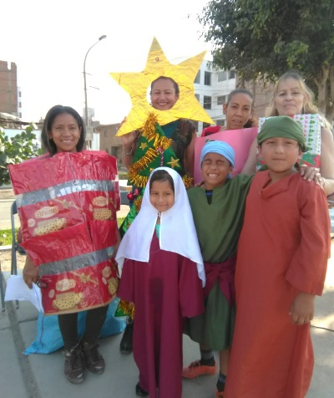
The chocolatada in Los Olivos on Saturday, Dec. 15, was a success, though we didn’t have the 80 children we had hoped for. We had about 30 children and 17 adults (not from our church) who learned about Christmas through the plays and brief message; and got to know some of our members. Our members showed up and did a great job. Bo and some of the members had good conversations getting to know people and inviting them to church. Unfortunately, only two moms and their children came to our service the next morning; but we are still in contact with them, and we are thankful that more people in the community now know about our church.
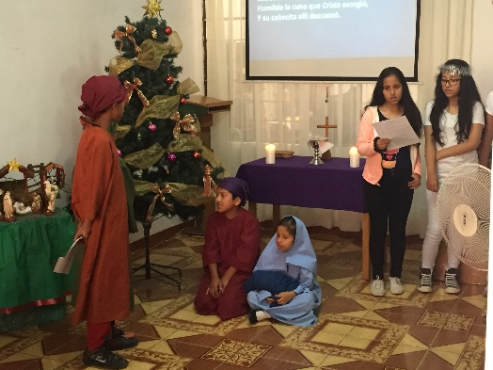
God blessed our Sunday, Dec. 23rd Christmas program and Christmas potluck in Los Olivos in many ways, but we got off to a very slow start. At 9:30, our usual start-time, only 2 people were present. We finally started at 10:00 a.m. with 18 people, none of whom were our actors for the children’s drama. But a Christmas miracle occurred. All 8 of them showed up at about 10:15, just in the nick of time. Bo rearranged the service and gave the actors time to get their costumes on by preaching his short message before their play instead of after it. The kids did a great job, and the adult drama also went well. By the end, 36 people were in attendance, including 4 visitors. There was a lot of fun and excitement during the delicious pot-luck meal. We had a great time celebrating Jesus’ birth together.

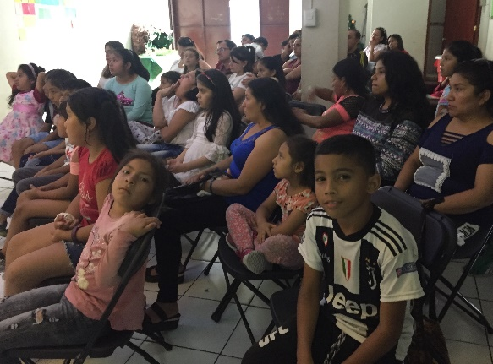
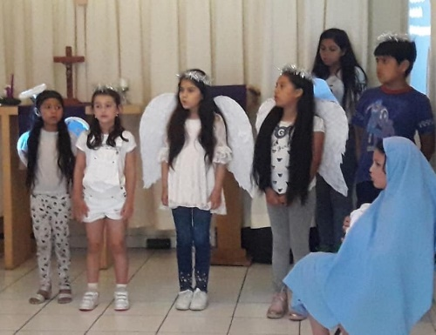
Our outreach chocolatada in La Victoria on Saturday, Dec. 22, also went well, especially in view of the fact that Pastor Osmel and Yolanda were away in Bolivia. We had an attendance of 49 people. Of these, 9 adults and 9 children are regular attenders at our worship services. Visitors included 19 children and 12 adults. None of the shepherds nor Joseph showed up for the children’s drama, but overall it went well. The adult drama also needed a few last-minute fill-ins. Both dramas communicated the Christmas gospel clearly. We sang lots of Latin American Christian Christmas songs. After the program, everyone received a cup of hot chocolate and a big piece of panetón (sweet-bread with dried fruit). Then each child received a Christmas gift. We were able to have lots of conversations with the unchurched parents who were visitors at the event, and to invite them to join us again. We believe that the Lord truly blessed the event.

Another custom we mentioned in our last letter was gifting panetón to family and friends. We, along with Osmel and Yolanda, enjoyed giving panetón, homemade Christmas cookies, and homemade Christian Christmas cards to the 7 neighbors in our building, and to other special people we have met in our neighborhood. One of them, the shy watchman, now greets us warmly every time we see him! It has been fun trying to build relationships with our neighbors.

Do you remember the Sunday evening evangelistic Bible study in San Borja which we mentioned in our November letter? For several weeks, we only had 4 in attendance, but at our Dec. 23rd meeting, we had 8 adults and 4 children! It will be fun to see if the group will continue to grow when we restart in January.
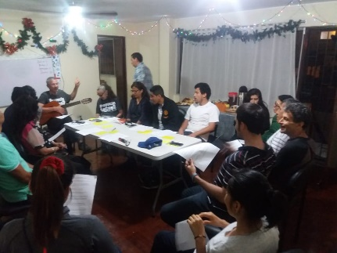

The San Borja Wednesday evening ESL class had a special Christmas celebration on December 19. 16 students joined us for good food and for a variety of games and songs that centered on the Christmas story. We keep praying that more of these students would join us in the Sunday evening Bible study.

Our next big opportunity to establish new contacts is through a short-term mission team from Mequon, WI, that will join us January 5 to 12. They have been preparing materials to teach an intensive, 15-hour, adult ESL course here in San Borja. They will also be teaching English to our Castillo Fuerte kids in La Victoria and offering their moms a course on children’s health. Our commitment will be to follow up on all the new contacts generated through the ministry of this team.

Praise the Lord:
- For the people who heard the Christmas gospel through our outreach chocolatadas
- That Pedro, Evie, Juliana and Eva continue to attend our San Borja Bible study
- That Solange continues to attend our worship services in La Victoria with her two daughters
Please ask the Lord:
- To bless the restart of our San Borja Bible study on January 13th
- To keep working in the hearts of Gonzalo, Carlos, Julio and Heber in San Borja
- To bless all the logistics for the Mequon, WI, short-term team: food and lodging, transportation, materials, health and safety, etc.
- To use the week of special ESL courses in such a way that many new contacts are established
- To keep working in the hearts of Elizabeth, Nelson and Wilson in La Victoria
- To bring home safely Pastor Osmel and Yolanda from their vacation in Bolivia

Thanks for praying for us, and Happy New Year to all of you!

Bo and Barb

