Lima, December 10, 2018

Merry Christmas to our Lima ministry support team!

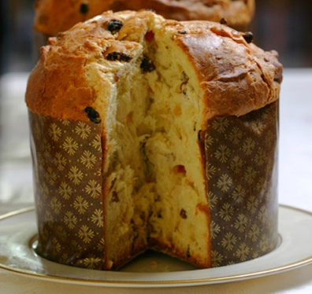
We are excited about our December evangelistic outreach events. Here in Peru there is a very predominant Christmas custom called the “chocolatada.” A group of adults chooses a target group of children, such as at a school, or in an apartment complex or neighborhood. These adults then purchase gifts for the children, usually a toy and a bag of fruit. They set a date and time when the “chocolatada” will take place. They purchase plenty of “Panetón” (sweet bread) and prepare a lot of chocolate milk. They may also plan entertainment, such as games and folkloric dances. As they are setting things up, the word spreads among the children that a “chocolatada” is about to take place. The children drop what they’re doing and stop by to pick up their Christmas gifts and chocolate milk. This happens frequently in December all over the city and throughout the country.

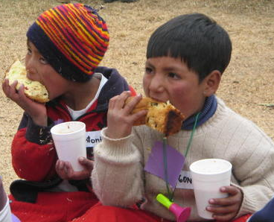
Our goal is to take this secular event and turn it into a chance to share the gospel with the children and their parents. In Los Olivos our evangelistic “chocolatada” will take place on Saturday afternoon, the 15th. We have permission to use a neighborhood sports complex near our church. We are purchasing about 80 gifts and fruit bags. We are preparing gallons of chocolate milk. When all is set up at the sports complex and the children and parents are gathered, we will introduce our church, and then present two short Christmas dramas, one by the children and one by the adults. Bo will give a brief, evangelistic children’s message and invite everyone to our special Christmas service the next morning. The gifts and chocolate milk will be handed out and we hope to have conversations with the parents.

In La Victoria our evangelistic “chocolatada” will take place on Saturday the 22nd, at our church, just before our evening worship service. The gifts, sweet bread and chocolate milk will be visible to all, but first we will share our dramas and short Christmas children’s message and some folkloric Christmas songs. Then the gifts and chocolate milk will be distributed, and the conversations can take place.

Please pray that these “chocolatadas” might be used by the Holy Spirit to draw more families closer to Jesus as their Savior and Lord. In our January newsletter, we will let you know how these events went, and also give you an update about the people for whom we asked you to pray in our last letter.
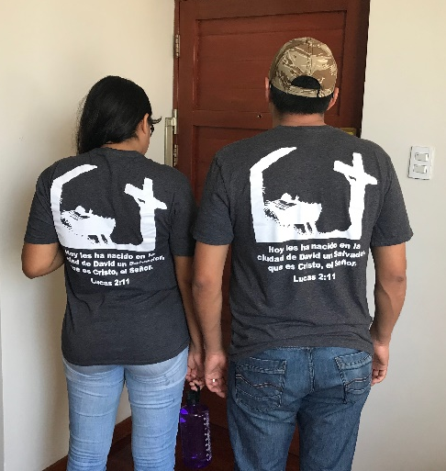
About 40 of our members and friends here in Lima are wearing special t-shirts this Christmas season. The message on the back declares that the real meaning of Christmas is that a Savior has been born for us. The graphic combines the manger and the cross, helping people understand why Jesus was born. These witnessing t-shirts were kindly donated to us by a member of our home church, Faith Community Lutheran in Las Vegas. If you would like to know more about this Christmas witnessing tool, please go to www.luke2project.org

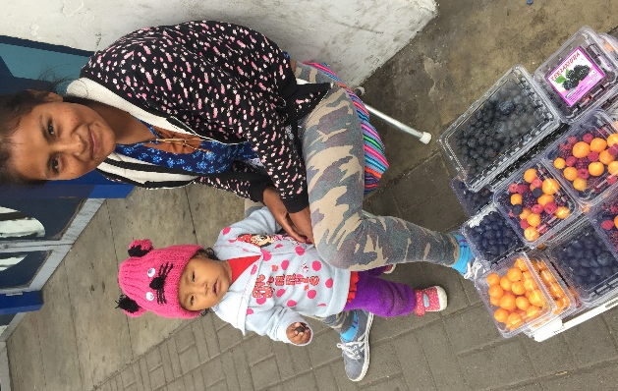
We have learned that it is customary to give Christmas gifts of “Panetón” and sometimes money to the service workers in our lives. There are 4 of these people whom we see regularly. One is the doorman at a construction site down the street from us. He always greets us as we pass by. Another is a watchman in our neighborhood who struggles to even make eye contact with us. The lady who cleans the common areas of our apartment building works very hard in spite of many aches and pains. A fourth is the sweet, young Quechua mom from whom we buy blueberries several times a week. We will give each of them a Christmas gift and include a card which shares the Christmas gospel message.

We were blessed to spend a week in the Cusco area, including Machu Picchu. We loved learning more about Peruvian history and culture. This area of Peru is amazing not only because of the fascinating Inca ruins, but also because of the stark beauty which God built into the Andes Mountains.

Praise the Lord for:
- sending Jesus to be our Savior
- special opportunities to share the Christmas gospel this month
- warmer weather and more sunshine
- a growing number of Castillo Fuerte parents visiting our La Victoria worship service
- the privilege of visiting Machu Picchu
- everyone who prays for us
Please ask the Lord for:
- blessings on the “chocolatada” evangelistic events, on the contact we make with the four special “friends,” and on the message communicated through our Luke 2 t-shirts
- a growing number of participants at our San Borja evangelistic Bible study
- His blessing on the process of bringing more missionaries to Lima
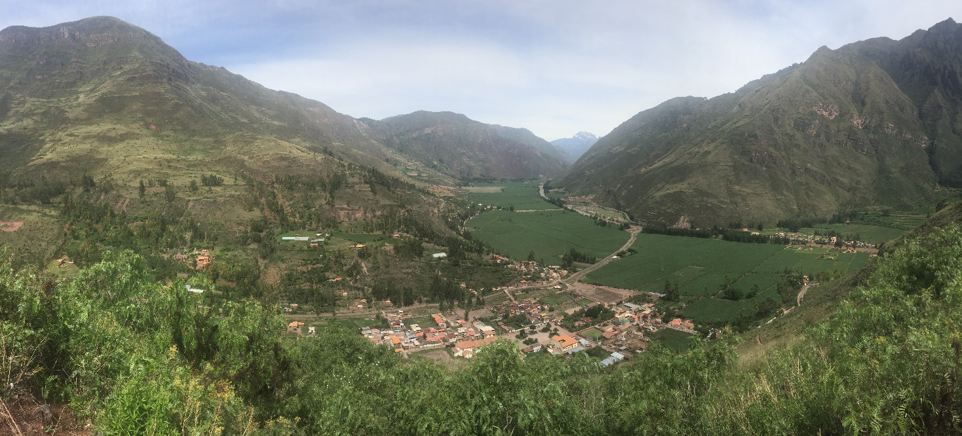
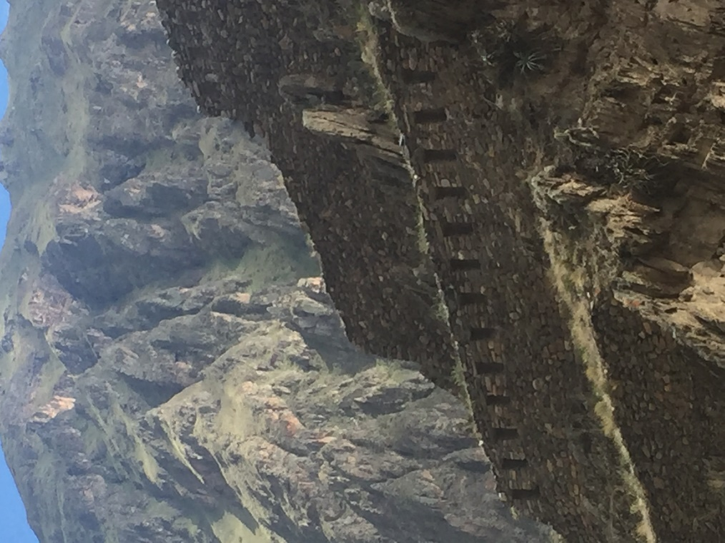
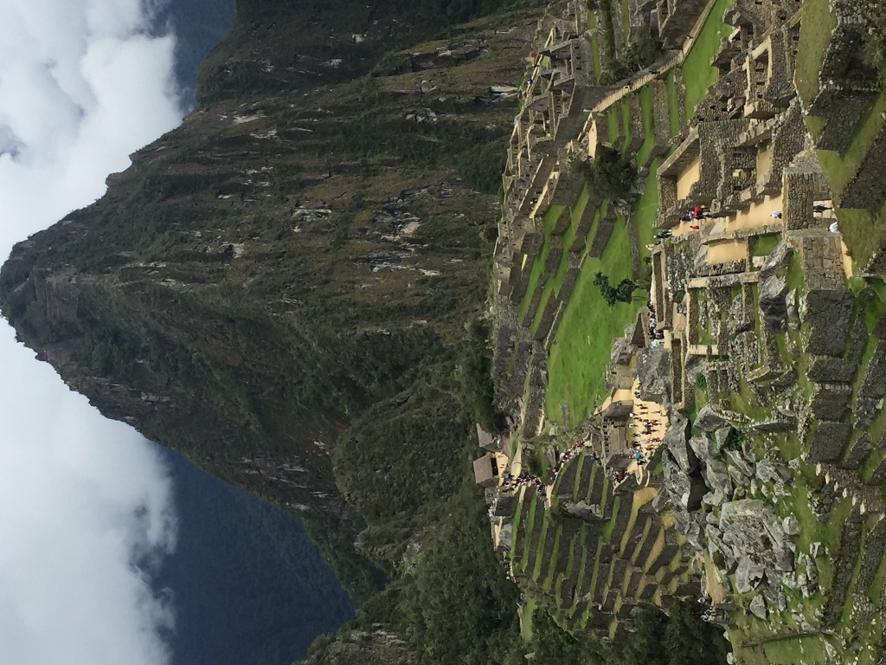
God bless you all this Christmas and in the New Year!

