November 19, 2018
Dear Friends of the Mission in Lima, Peru,
In this letter we will give you updates for each of our three mission sites in Lima and share highlights of some of the places in Peru we have had the pleasure to visit.
Our mission office is located in San Borja. The ministry in this neighborhood has been going on for at least three years, with mainly an ESL outreach. We have continued the English class on Wednesday evenings, with one hour of grammar and conversation, and one hour of English Bible study. We have an average of 12 participants, several of whom have expressed an interest in learning more about the Bible and salvation. Please pray for Carlos, Gonzalo, Julio, and Heber.
In addition, we have just begun a new Sunday evening Spanish evangelistic Bible study. Based on the good work done by previous missionaries, we were able to invite 14 people. Last night, 4 of them attended. Please especially pray for Pedro, Evie, Juliana and Eva. We have high hopes that up to 8 may attend next Sunday. If the number of attendees grows sufficiently, it could become the core group of a new church plant.
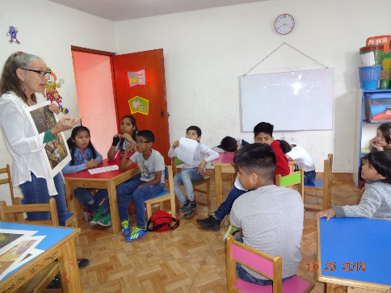
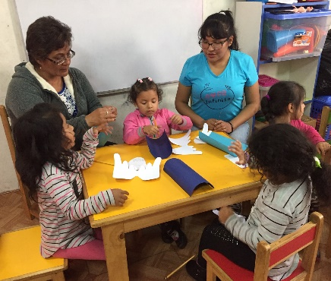
In La Victoria, our special Saturday afternoon Bible school for children has grown from an average of 6 in the first month to an average of 16 in the last four weeks. Barb and Yolanda are thankful that the children come on their own initiative, listen intently to the Bible stories, ask good questions, and enjoy group conversation, songs and crafts. Please pray for Kiara, Alex, Sebastian and Juaquin.
Reaching the parents of these children is a difficult task. On the positive side, 4 parents have recently attended at least one worship service. Please pray for Solange, Elizabet, Nelson and Wilson. What is proving to be more challenging is getting the parents into Bible study. Even though Pastor Osmel has been doing a great job of visiting many in their homes and inviting them to study the Bible with him, none have attended. We think the new strategy may be Bible studies in individual homes, but homes are tiny and schedules are difficult. Please pray for Pastor Osmel as he persists in this church planting challenge.
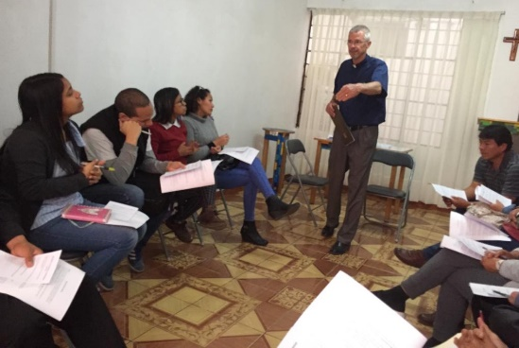
In Los Olivos, though Satan is working overtime to cause discord and interpersonal strife, Jesus continues to grow His church. Average worship attendance has grown from 23 in the first month to 34 in the second. Almost everyone stays for Sunday school and Bible class. Our action support teams are slowly gaining momentum. Bo and Barb are working at visiting everyone in their homes. 8 ladies are studying a mid-week prayer course with Barb. Bo’s lay leadership training course has dwindled from 12 to 8 regular attendees. Please pray for Gabriel, Doris, Yepci, Jorge and Betania.

We have been trying to take every Monday off for relaxation and sight-seeing. We enjoyed watching the changing of the guard at the presidential palace and walking along the boardwalk at the ocean front. We have visited interesting museums of history, archeology, and art. Traveling four hours out of Lima through the Chillón River Valley and up into the mountains to see snow and lakes and waterfalls filled a long and enjoyable day. And right here in the middle of Lima, we were fascinated as we toured a site of ancient ruins. We are thankful for the opportunity to see so much of this beautiful country.
Praise the Lord for:
- leading us to so many special people whom He has prepared in advance to hear His Word and come to faith in Him.
- allowing us to live here and get to know the people and culture and special sights of Peru.
- for current good health
- for encouraging us when we get frustrated.

Please ask the Lord to:
- work in the hearts of all the folks we have mentioned.
- foil Satan’s attempts to prevent this ministry from prospering.
- clearly guide our plans and strategies to make the most of our time here.
- be setting into motion whatever needs to be done to bring another missionary here before we leave in April, 2019. May He already be preparing that person for service here.

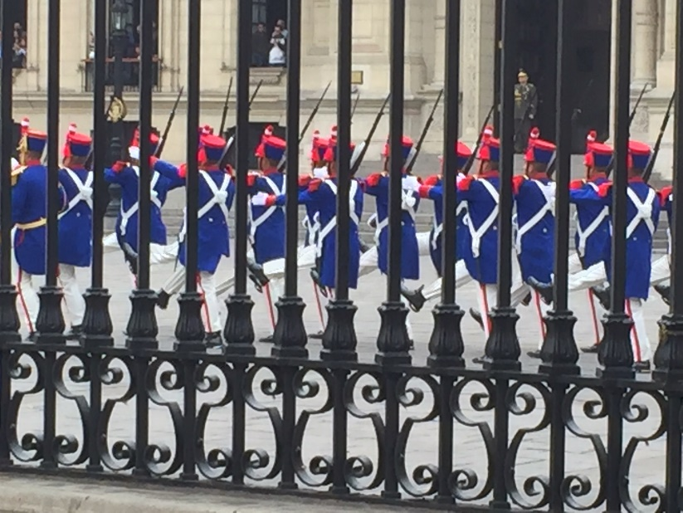
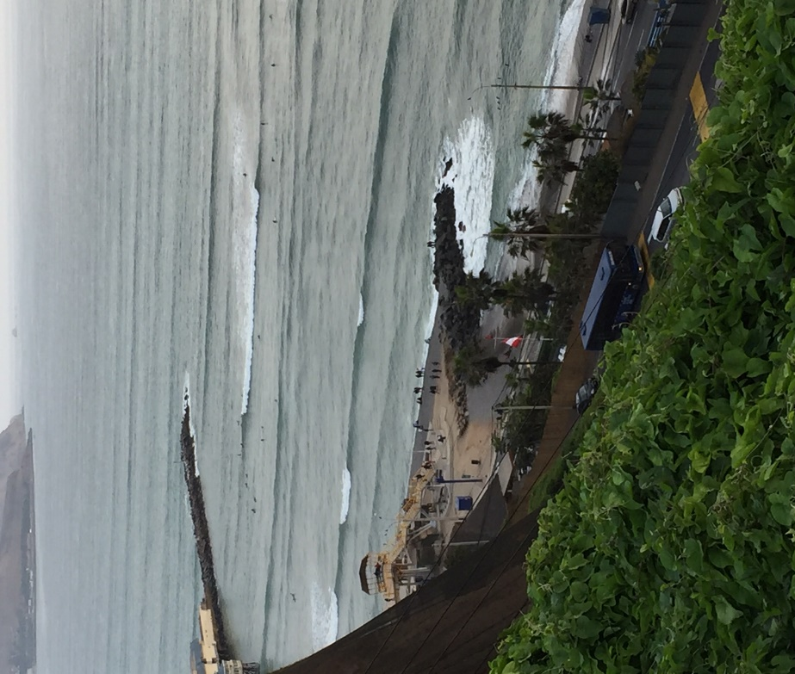
Changing of the guard

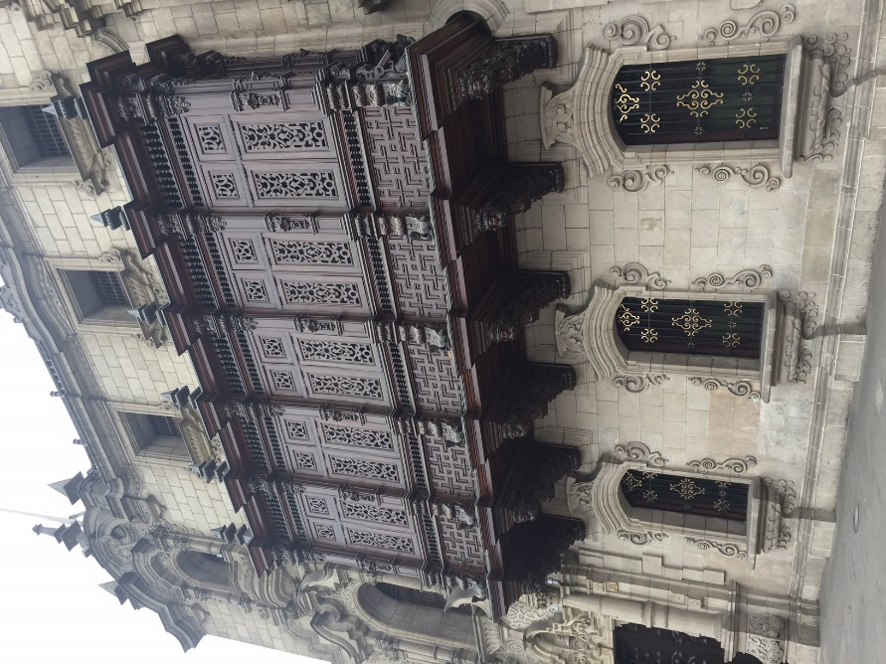
At the Pacific
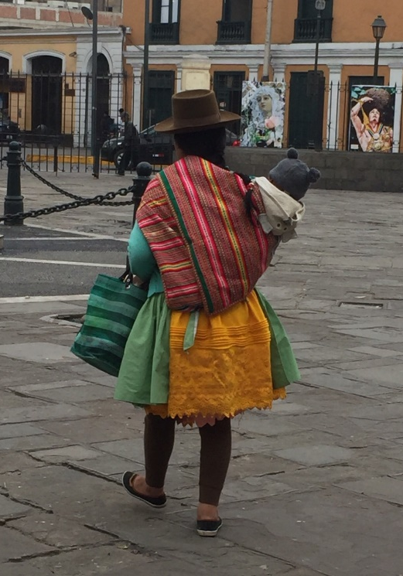

On Lima’s Main Square
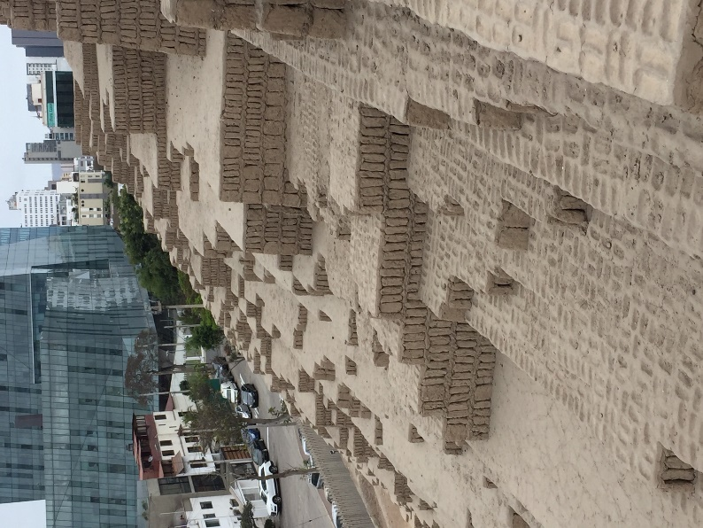
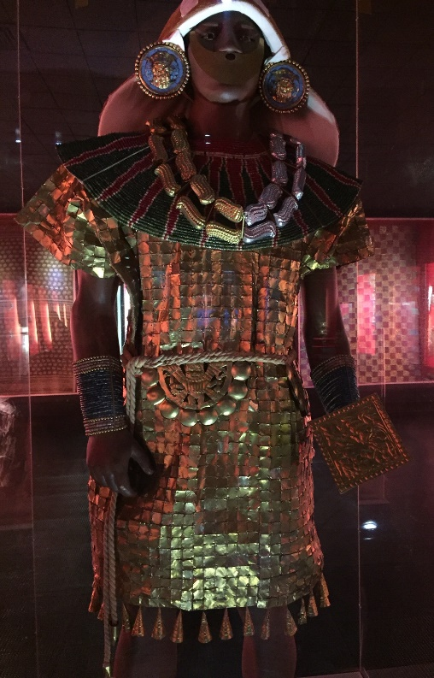

Pre-Incan ruins (200-700 A.D.) in central Lima Gold Museum

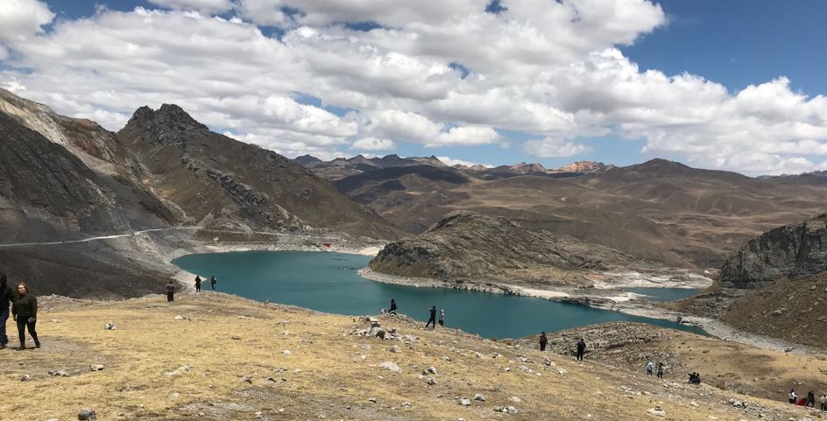

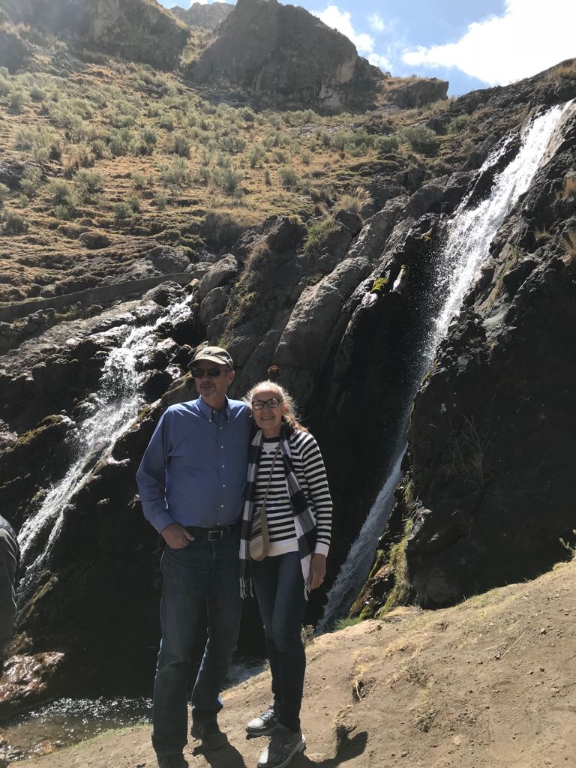
In the mountains

