Sept. 23, 2018
Hi Everyone. Thanks for all your prayers. The Lord has been blessing us in many ways.

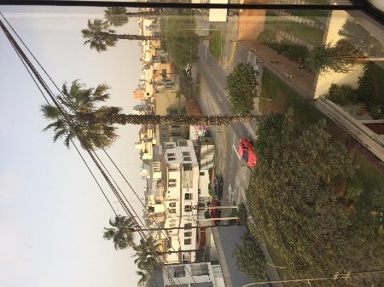
We arrived to Lima last Sunday afternoon, and our new friend Teo Purihuaman was waiting for us at the airport with a taxi-van for our luggage. She brought us to our apartment (picture shows view from our front window) in an area of Lima called San Borja, cooked supper for us and walked us to the supermarket for our first groceries.

We had our new Peruvian phone card and numbers by the next evening. Our mission office business manager Lucho helped us take care of that.
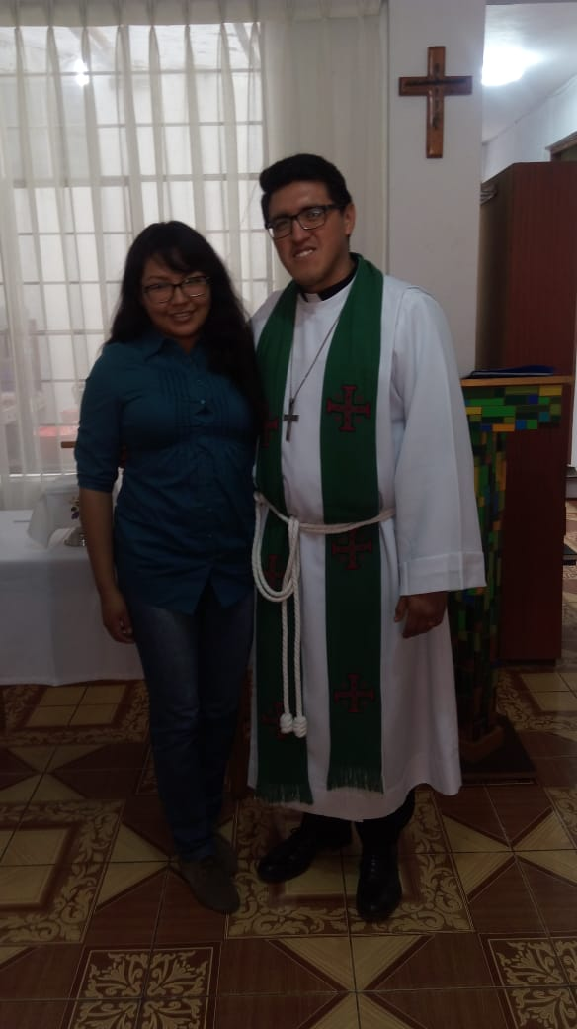
Our apartment-mates, Pastor Osmel and Yolanda Solis, arrived on Tuesday. They had been to Potosi, Bolivia, over the weekend for Osmel’s ordination. We are enjoying being with them as we share time here at the house and as they teach us all about our three ministry sites around Lima.

For those of you who didn’t hear about the change in our ministry description: We were going to be working alongside three career missionary families, but they have all left Peru. As a result, we will be working only with Pastor Osmel and Yolanda for our time here.

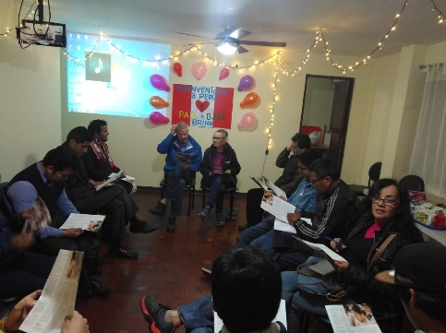
On Wednesday evening we learned about our ESL outreach ministry here in San Borja. About 15 students participated in the weekly event called “Coffee and Conversation.” We enjoyed meeting all of them and are thinking about how we can help them be drawn closer to Jesus.

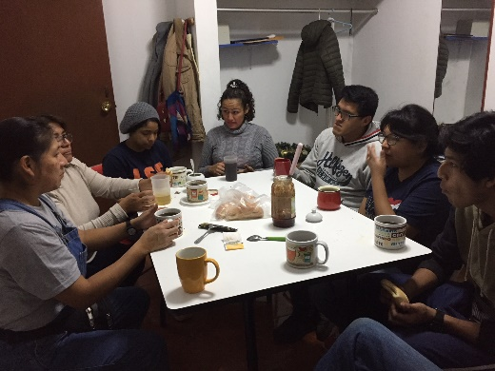
On Thursday afternoon we went to our mission site in Los Olivos. It took us an hour and 45 minutes to get there in public transportation. Not only is Lima huge, the traffic is just overwhelming, much worse than anything we have ever seen. Our little church rents the first floor of a house. We met there to help with a deep cleaning of the site and to participate in an organizational meeting with the Sunday School teachers. Today (Sunday), we were back at Los Olivos for worship. 23 people attended worship and 16 stayed for Bible class after church. The people are very friendly and we have lots of ideas about how to help the little church grow in number and ministry effectiveness.

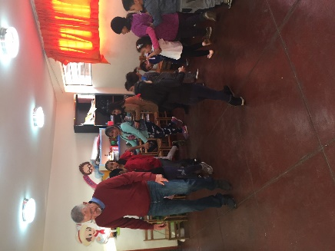
On Friday and Saturday Osmel and Yolanda took us to La Victoria. In this industrial neighborhood we have a children’s ministry called Castillo Fuerte (an after-school program which includes lunch, Christian education and help with homework), and a very small congregation. On Friday we enjoyed playing with the children and teaching them some songs, and on Saturday we participated in their worship service. Only 4 adults and 3 children attended. We are studying ways to effectively reach out to more of the parents of the children of Castillo Fuerte and to the neighbors who live around the church.

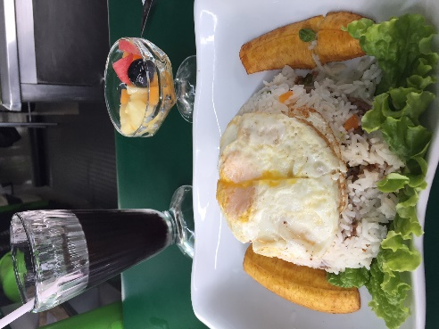
Here are a few interesting aspects of our new life in Lima. The weather has been very chilly (in the low 60’s) with almost no sunshine at all. We have no heating or cooling in the apartment, just a dehumidifier. As we learn how to use public transportation, we have been walking many miles every day. We get additional exercise walking up and down the four flights of stairs at our apartment several times a day. Grocery shopping takes a lot of time. We run into Venezuelans everywhere we go, as they have been forced to leave their country because of the communist-induced poverty. Two very typical Peruvian foods which we have already enjoyed are “mazamorra morada,” a jello-like dessert made from purple corn, and “chicha morada,” (pictured) a beverage made from the same purple corn.

Praise the Lord for:
- safety in travel
- wonderful living and ministry companions
- a comfortable apartment
- exciting ministry challenges and fun culture-learning

Prayer requests:
- for the Lord’s guidance in knowing how to capitalize on the opportunities provided by “Coffee and Conversation”
- for wisdom in knowing how best to reach the families of the children who attend Castillo Fuerte
- for His guidance in knowing how to effectively help the little church in Los Olivos grow in number, maturity and outreach
- for protection in this huge city
- for health in spite of the thick air pollution
- for Pastor Osmel and Yolanda, missionary partners from Bolivia

We hope to be back in touch in about two weeks.
Thanks for being part of this ministry in Lima.
Bo and Barb

