The Lutheran Church Missouri Synod
The Taiwan Times

Andrew and Noel Schaff Missionary Newsletter from ChiaYi, Taiwan

July - August 2018

“All that the Father gives me will come to me, and whoever comes to me I will never cast out. For I have come down from heaven, not to do my own will but the will of him who sent me. And this is the will of him who sent me, that I should lose nothing of all that he has given me, but raise it up on the last day. For this is the will of my Father, that everyone who looks on the Son and believes in him should have eternal life, and I will raise him up on the last day.” John 6:37-40
Fellowship in Loneliness


Loneliness. It is an experience with which all humans are familiar. Even while flooded by people and events as missionaries in Taiwan, there is a certain loneliness that exists. Andrew and I have lived much of our lives on both sides of the world. Both sides which have extremely clashing cultures and both which hold a level of familiarity to us. The result is a feeling of a third, own culture. The feeling of never quite understanding or fitting into one or the other.
Isolation. This year I have experienced a lot of isolation as the result of lengthy hospitalization. I was cut off from familiar people and tasks for many months as the result of illness. To this day, there remains a sense of loneliness known only by those who suffer from chronic illness. Meanwhile Andrew experiences alone what it is like to be the spouse of a chronically ill person.
I am not writing this way to discourage people. This month as I was reading John six, it struck me all the ways that each person experiences his or her own sense of separation. Perhaps it is our Taiwanese brothers and sisters who are the lone Christian believers outcast by their families. For others it is a mother at home all day with her young children – loving her task yet wondering if anyone notices or understands her. It might be the widow or person who has lost a close loved one feeling that no one else quite feels their pain. It might be someone overwhelmed and drowning in the responsibilities of the workplace. Whatever the form of loneliness, everyone knows it and it all stems from the same place. As noted in the Bible, it is the result of sin and living in a sinful, imperfect world. Sin has cut us off from God. Sin’s punishment – death cuts us off from those we know and love. We are even cut off from ourselves and our true identities in a way. But no human being has ever experienced separation and loneliness like Christ did.
Having known perfect unity with the father we are reminded in Hebrews how Jesus willingly became man and lived on earth. He then subjected himself to the ultimate separation – one that Christians do not know. On the cross, Jesus was completely forsaken by the Father as he cries out the words from the Psalm, “My God, My God, why have you forsaken me?” There is not a more final isolation that exists. Jesus was more powerful than even this isolation and was raised to life and returned to the presence of the Father. In John six, he reassures all those in Christ that He will never cast away those who come to him. The word that stuck out to me was NEVER. No matter our struggles in life, or the sins we commit Jesus could never love us any more or any less. And for the course of our earthly lives, He will never turn us away.
What comfort that no matter how deep the dark hole we are in or how far removed from all else, we are never alone in Christ! We have one that knows us more intimately and loves us more deeply than we can even comprehend. He hears our prayers and pleads to the Father on our behalf. Amidst the deepest loneliness, there is rich fellowship in our Savior.

He lives to bless me with His love,
He lives to plead for me above,
He lives my hungry soul to feed,
He lives to help in time of need.

He lives to grant me rich supply,
He lives to guide me with His eye,
He lives to comfort me when faint,
He live to hear my soul's complaint.

He lives to silence all my fears,
He lives to wipe away my tears,
He lives to calm my troubled heart,
He lives all blessings to impart.

He lives, my kind, wise, heavenly friend,
He lives and loves me to the end;
He lives, and while He lives, I'll sing;
He lives, my Prophet, Priest, and King.

“I Know that My Redeemer Lives” v. 3,4,5

I was able to visit Mission Central this summer to talk about Taiwan and share the message of Christ to a church group from Iowa.

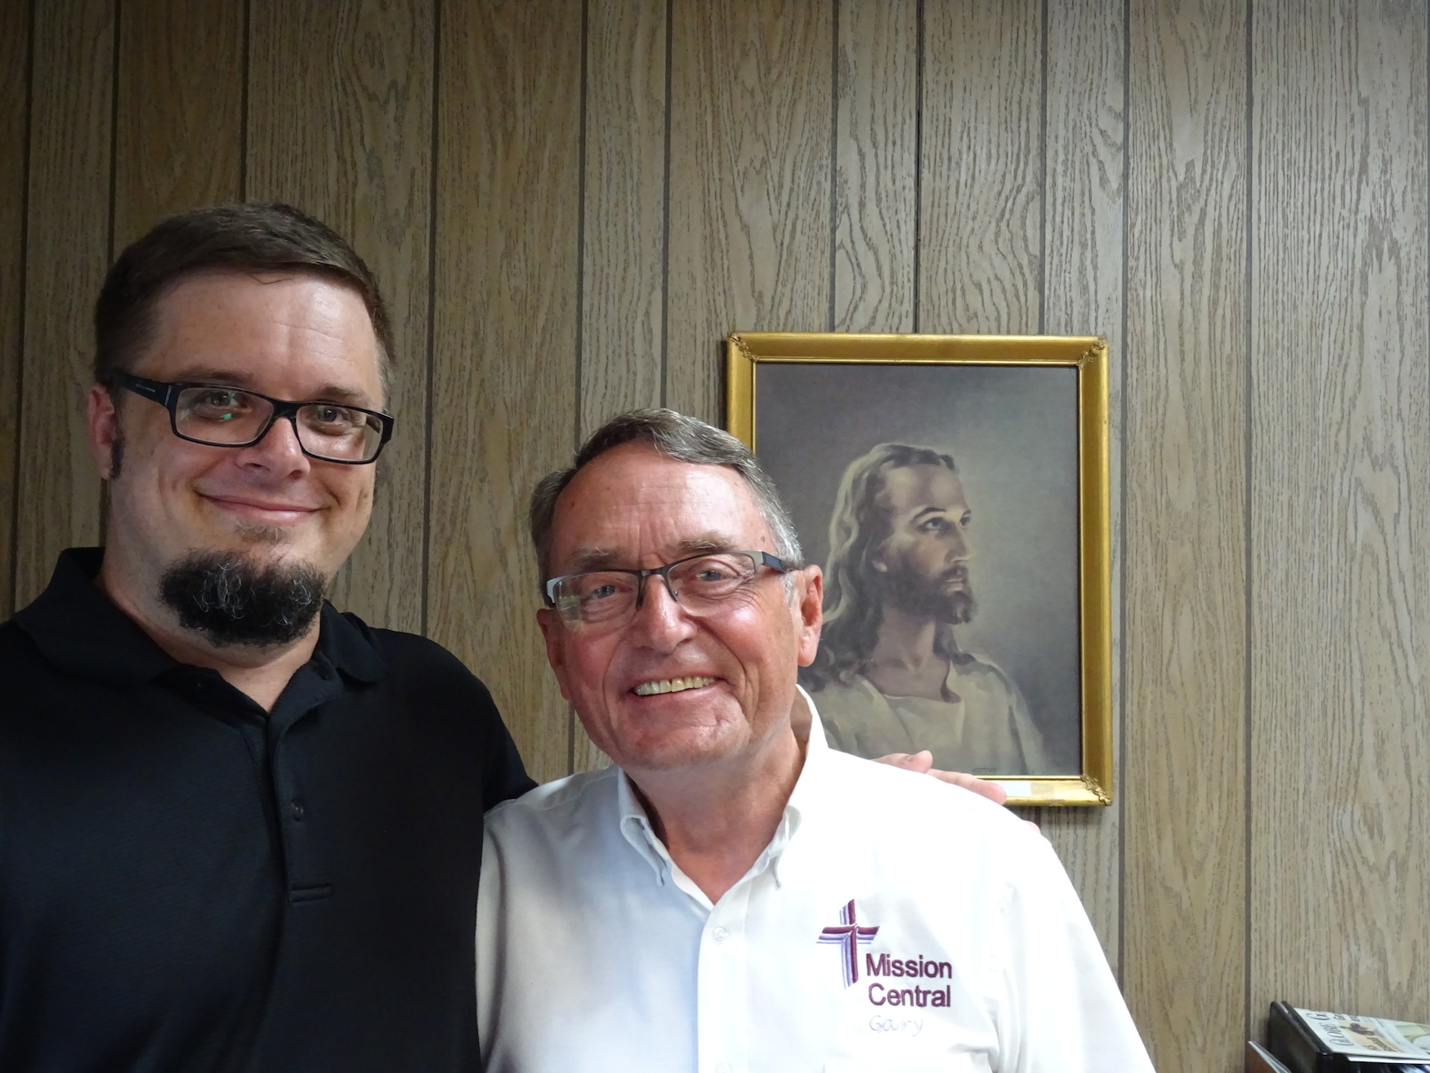

Noel and I visiting with Noel’s sister and boyfriend.


This summer I had an opportunity to go camping with my family in Michigan.

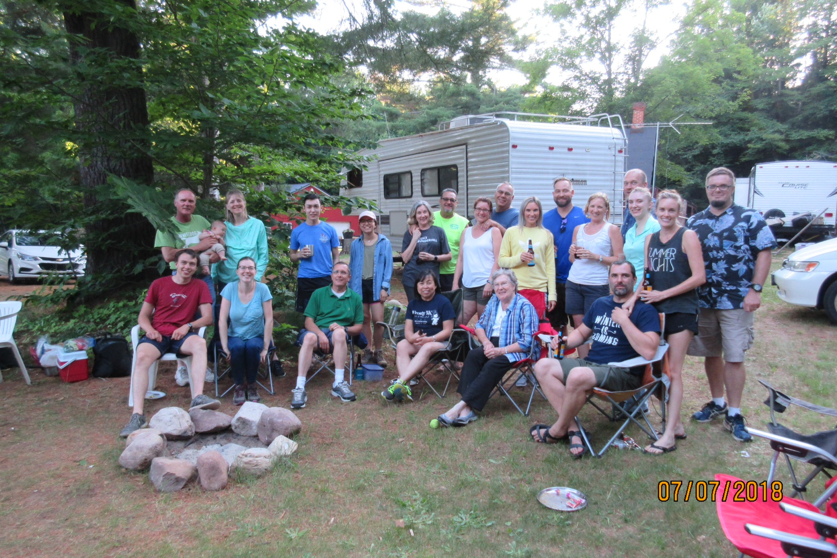


Prayer Requests
- Praise God for a wonderful time of fellowship and encouragement with family, friends, and coworkers in Christ here in the States during our visit this summer.
- Pray for us and our tutoring students Ting, May, Melody and Sara as we return to teach them this year. Pray that the Lord would plant and grow the seeds of faith in their hearts.
- Pray for Andrew as he prepares to begin a new semester at CMS. Pray that the Lord would equip and strengthen him and keep him faithful to the word in his service.
- Pray for several new missionary families who will be joining service in Taiwan next year. Pray that the Lord would help their arrangements and adjustment to Taiwan. Pray that the Lord would use us to help serve in their acclimation.
throu

Andrew and Noel Schaff
#31 Chien-Kuo Rd. Sec. 2
Min-Hsiung, ChiaYi 621
Taiwan R.O.C.

Phone: 011-886-984-397-996

We Thank God for You!

Your prayers and encouragement are greatly appreciated! If you would like to financially support the ministry in Taiwan, please make checks payable to LCMS World Mission, clearly designating for Andrew and Noel Schaff, and send to:

The Lutheran Church Missouri Synod
1333 S. Kirkwood Road
St. Louis, MO 63122-7295

Or adopt us as missionaries through Mission Central in Mapleton, IA. You can contact our friends at Mission Central using the following address:

Mission Central
40718 Highway E 16
Mapleton, Iowa 51034
Phone: 712-882-1029
You can email Gary at Gary.Thies@lcms.org

“I always thank my God as I remember you in my prayers, because I hear about your faith in the Lord Jesus and your love for all the saints.” Philemon 2:4

Pray for Us
Andrew and Noel Schaff

Thanks!
Thank you for all of your prayers and financial support! Your prayers, mail and email continually encourage us. We look forward to sharing more of what the Lord is doing in Taiwan with you in upcoming newsletters.

Peace in Christ,
Andrew and Noel Schaff

Email us at:
noel_beth19@hotmail.com



