The Lutheran Church Missouri Synod
The Taiwan Times

Andrew and Noel Schaff Missionary Newsletter from ChiaYi, Taiwan

May 2018

I therefore, a prisoner for the Lord, urge you to walk in a manner worthy of the calling to which you have been called, with all humility and gentleness, with patience, bearing with one another in love, eager to maintain the unity of the Spirit in the bond of peace. There is one body and one Spirit—just as you were called to the one hope that belongs to your call—one Lord, one faith, one baptism, one God and Father of all, who is over all and through all and in all. Ephesians 4:1-6

Mirror, Mirror


Though we seldom think of it, mirrors play an important role in our every day lives. We use them to make sure we look tidy for the day. They play a vital role in our safety on the road to see what is around us. They create a sense of more light and space in enclosed places. Mirrors provide a source of notification for us about the status of our bodies.
In Taiwanese culture mirrors play several important roles in folk religious beliefs. Temples have huge mirrors in entrances. Their purpose is to scare away ghosts or evil spirits. They are also there to reveal to other temple-goers whether or not someone entering the temple is a ghost. If someone enters and a reflection is not seen, the person is not living.
Mirrors are believed to affect the energy and flow of the home as well. A student once saw a mirror near the entrance of my house and gasped. When I asked why, the student replied that having a mirror so close to the entrance of my home would remove all of the good “chi” or energy from my home. Many Taiwanese believe it is important to have mirrors in the home in which you see yourself completely and not in small pieces. This is thought to affect one’s identity.
While studying Ephesians this week, I thought about mirrors. I was convicted. I find myself glancing in the mirror all the time throughout the day. The amount of time I spend going to the mirror of God’s Word to find out about my true identity pales in comparison. Though I focus so much on the former mirror, the latter mirror reveals the most about me and what matters.
The mirror of God’s word speaks to me about who God is. It is in knowing who God is that I learn who I am in Christ. In this mirror I see that God is an all-powerful Creator, Redeemer, Sanctifier, Father, Friend. The reflection in the Bible reveals me to be sinful, saved, sanctified, a child of God, called to sacrifice and service. It is when I know who God tells me I am that I most know my true identity. This made me realize that in all of the times in a day I catch a reflection of myself, if I turned to God’s word to be reminded of who I am in Christ; my life would be a clearer picture of who I have been made in Jesus. I pray that more of my life would reflect the child of God that I am in Christ.
Update
Please especially pray for my tutoring student and friend, May. I have been praying that she would know Jesus for some time and that God would open doors to bring her to hear more of God’s word. Just recently her one Christian son moved to Taiwan. I had told her about Friday Night Bible Class for some time, but this week I mentioned it to her again. This time she expressed interest and said she would like to visit. She also expressed that she would like her son to be able to visit our church to find a church home. Please pray that the Lord would continue to work in these circumstances and open May’s heart to faith in His Word.
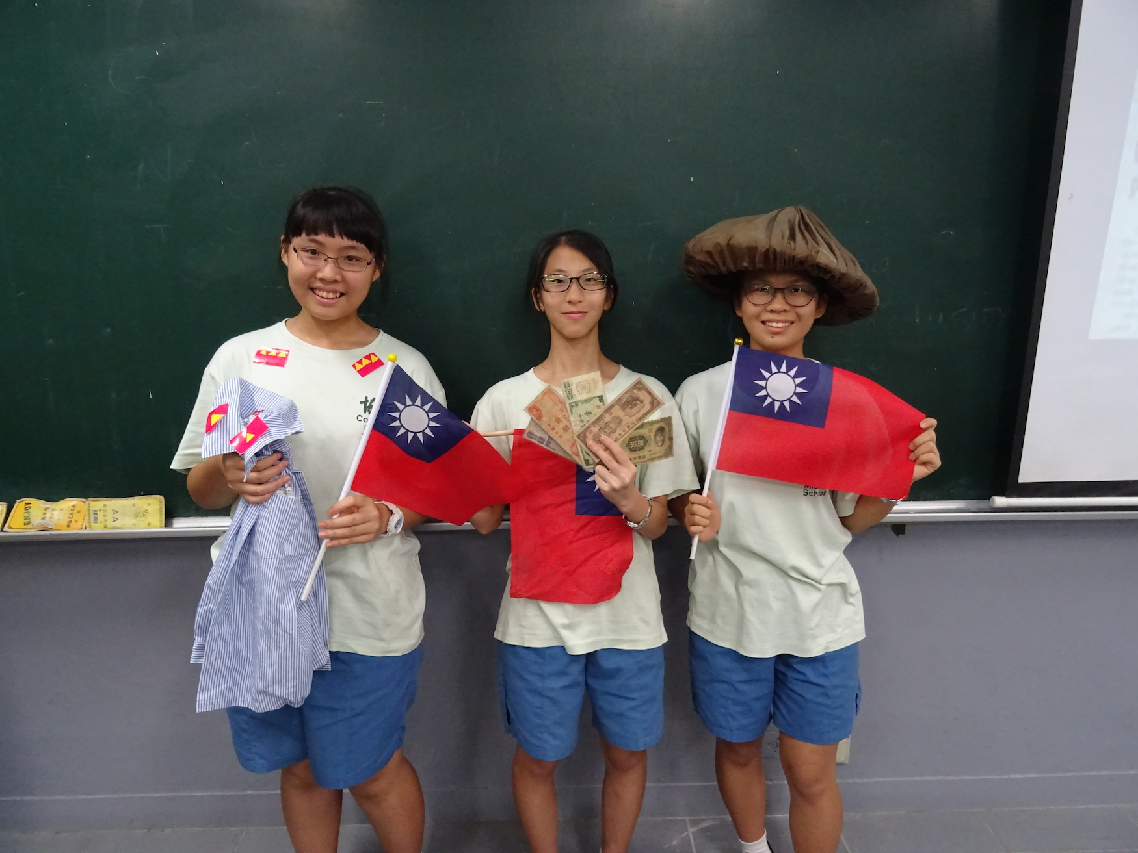
Students giving a presentation about WWII in China.

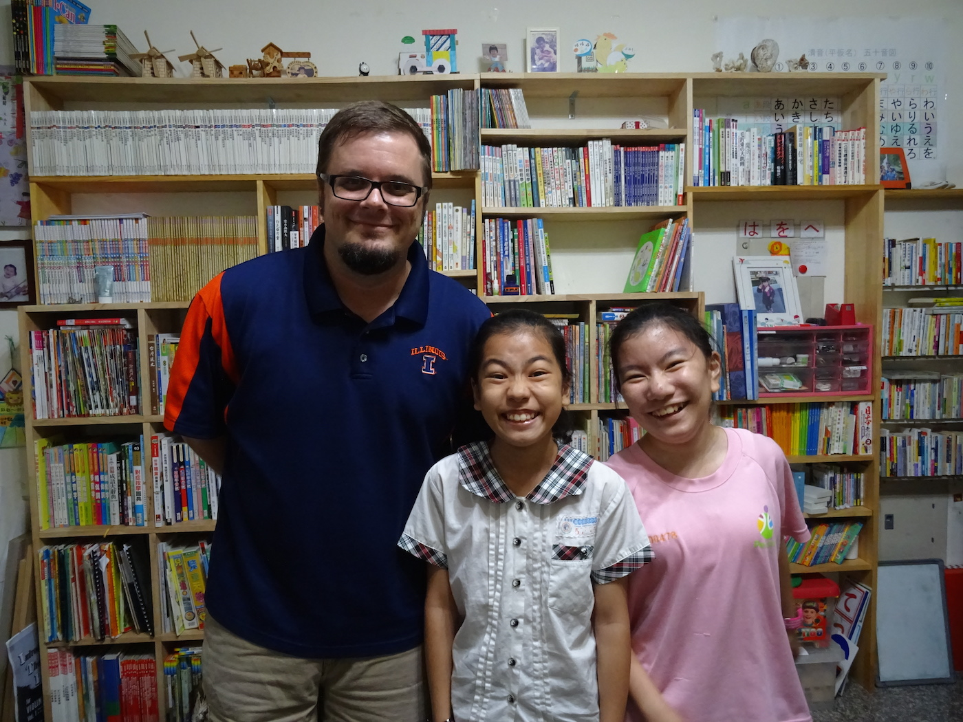
Two students I tutor: Melody and Sarah.

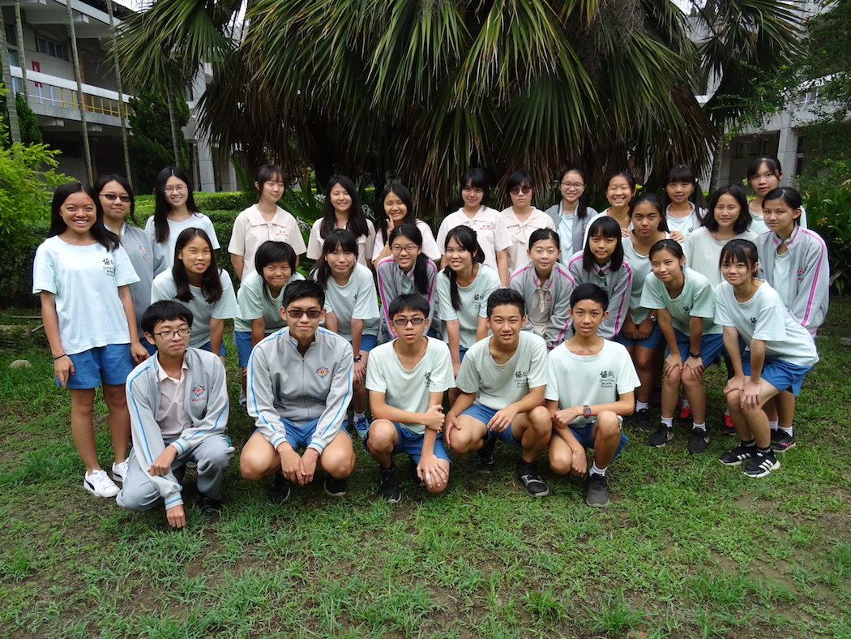
End of the year class picture of my 9th grade class.


Prayer Requests
- Please pray for us as we prepare to visit family and doctors in the States in late June and July. Pray that the Lord would bless the time in fellowship and refresh us for another year of service in Taiwan.
- Continue to pray for our tutoring students Ting, May, Melody and Sara.
- Pray for all of Andrew’s students who attend Friday Night Bible Study during summer break. Pray that they would continue to visit Salvation or other Christian churches where they would be nourished in the faith.
- Pray for several new missionary families who will be joining service in Taiwan next year. Pray that the Lord would help their arrangements and adjustment to Taiwan. Pray that the Lord would use us to help serve in their acclimation.
throu

Andrew and Noel Schaff
#31 Chien-Kuo Rd. Sec. 2
Min-Hsiung, ChiaYi 621
Taiwan R.O.C.

Phone: 011-886-983-397-996

We Thank God for You!

Your prayers and encouragement are greatly appreciated! If you would like to financially support the ministry in Taiwan, please make checks payable to LCMS World Mission, clearly designating for Andrew and Noel Schaff, and send to:

The Lutheran Church Missouri Synod
1333 S. Kirkwood Road
St. Louis, MO 63122-7295

Or adopt us as missionaries through Mission Central in Mapleton, IA. You can contact our friends at Mission Central using the following address:

Mission Central
40718 Highway E 16
Mapleton, Iowa 51034
Phone: 712-882-1029
You can email Gary at Gary.Thies@lcms.org

“I always thank my God as I remember you in my prayers, because I hear about your faith in the Lord Jesus and your love for all the saints.” Philemon 2:4

Pray for Us
Andrew and Noel Schaff

Thanks!
Thank you for all of your prayers and financial support! Your prayers, mail and email continually encourage us. We look forward to sharing more of what the Lord is doing in Taiwan with you in upcoming newsletters.

Peace in Christ,
Andrew and Noel Schaff

Email us at:
noel_beth19@hotmail.com



